Government Polytechnic Kashipur

(U.S. Nagar)



Semester: - 3rd

Session (2024-2025) Winter

Branch: -Information Technology

Subject: - Office Application

Batch (2023-2026)

Submitted To: Submitted By:

Ms. Neha Bora Aman Diktiya

Lecturer IT 23009120017

**Date-**

**WORD PROCESSING**

**INTRODUCTION**

Microsoft word is word processor software developed by Microsoft in 1983. It is the most commonly used word processor software. It is used to create professional quality documents, letters, reports, resumes, etc and also allows you to edit or modify your new or existing document. The file saved in Ms Word has docx extension. It is a component of the Microsoft Office suite, but you can buy it separately and is available for both Windows and macOS. The latest version of Ms Word is 2019. Examples include: Microsoft Works Word Processor, Open Office Writer, Word Perfect and Google Drive Document.

**CREATING NEW DOCUMENT**

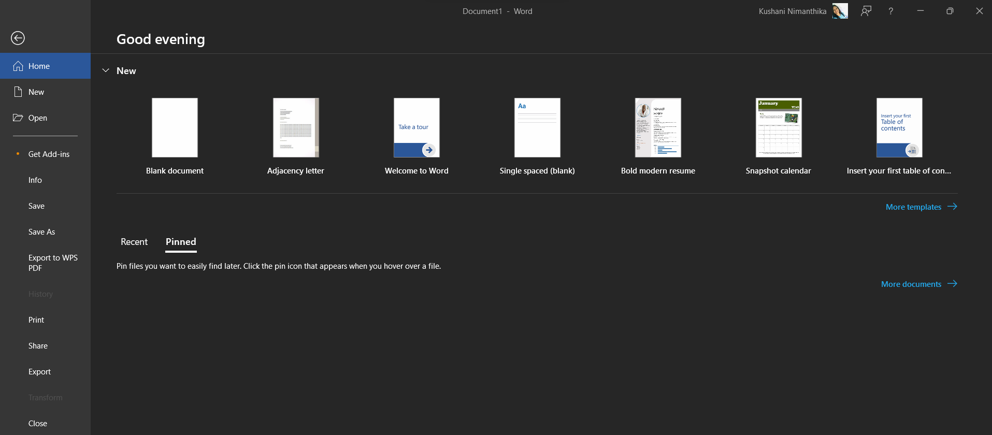Creating a Word document is a fundamental skill that allows you to compose letters, reports, and various types of documents. Here's a simple step-by-step tutorial to help you get started:

Figure 1.Microsoft Word

To insert Word document into Word document, there are steps that needs to be followed as seen below.

* 1. First open the document that would be the receiver of the existing file.
  2. Let your cursor be in the place that the file will go.

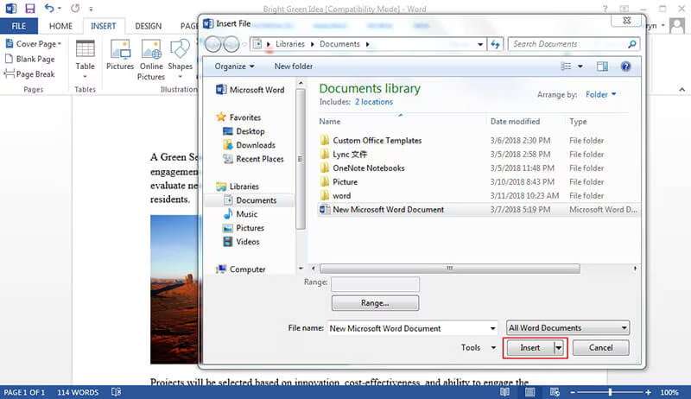3. Go to "Insert" tab > "Text" section > "Object" and then “Text from File”.

Figure 2.Creating a new document

**PAGE LAYOUT**

In graphic design page layout is the arrangement of visual elements on a page. It generally involves organizational principles of composition to achieve specific communication objectives.

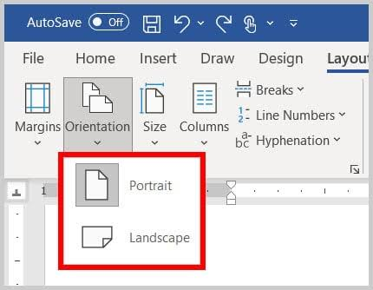

Figure3.Page Orientation

**FONTS:**

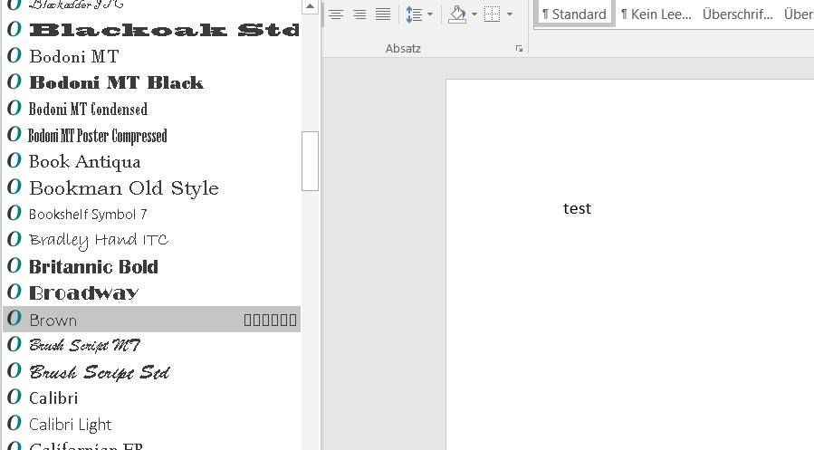

Figure 4.Fonts e.g.

Many stylish Fonts are available in MS Word to make the document more stylish. It is found just above the font tab.

**Alignment:**

Alignment is how text flows in relation to the rest of the page (or column, table cell, text box, etc.). There are four main alignments: left, right, center, and justified.

1. **Left-aligned text** is text that is aligned with a left edge.
2. **Right-aligned text** is text that is aligned with a right edge.
3. **Centered text** is text that is centered between two edges.

To align or justify text, move your cursor into the paragraph you want to change, then click the left-align, right-align, entered, or justify buttons.

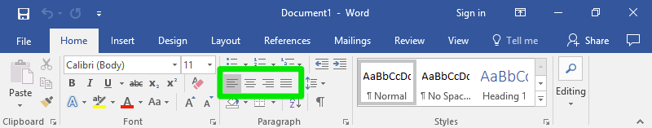

Figure 5.Types of Alignment

**Page Breaks:**

A page break is a special marker that will end the current page and start a new one.

1. Click to place your cursor where you want to start a new page.
2. Click the **Insert** tab.
3. If necessary, expand the **Pages** group by clicking it.
4. 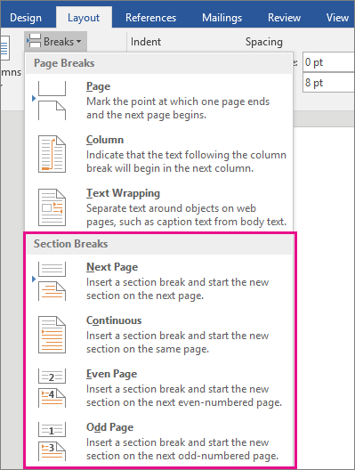Click the **Page Break** button.

Figure 6.Page Break

**Header and Footer:**

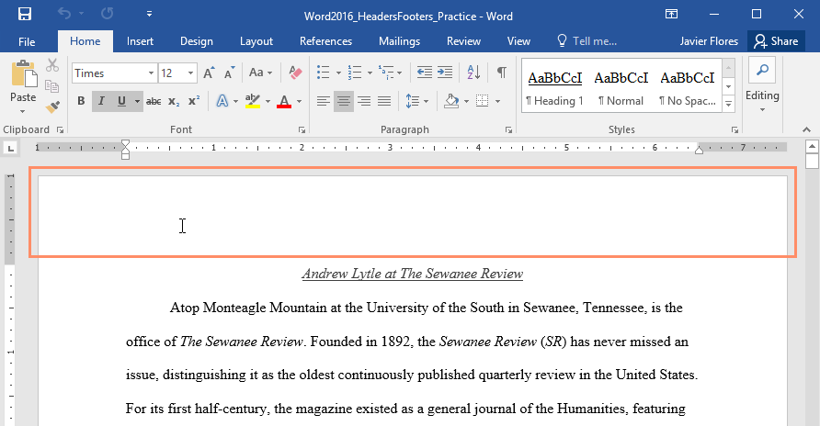The header is a section of the document that appears in the top margin, while the footer is a section of the document that appears in the bottom margin. Headers and footers generally contain additional information such as page numbers, dates, an author's name, and footnotes, which can help keep longer documents organized and make them easier to read. Text entered in the header or footer will appear on each page of the document.

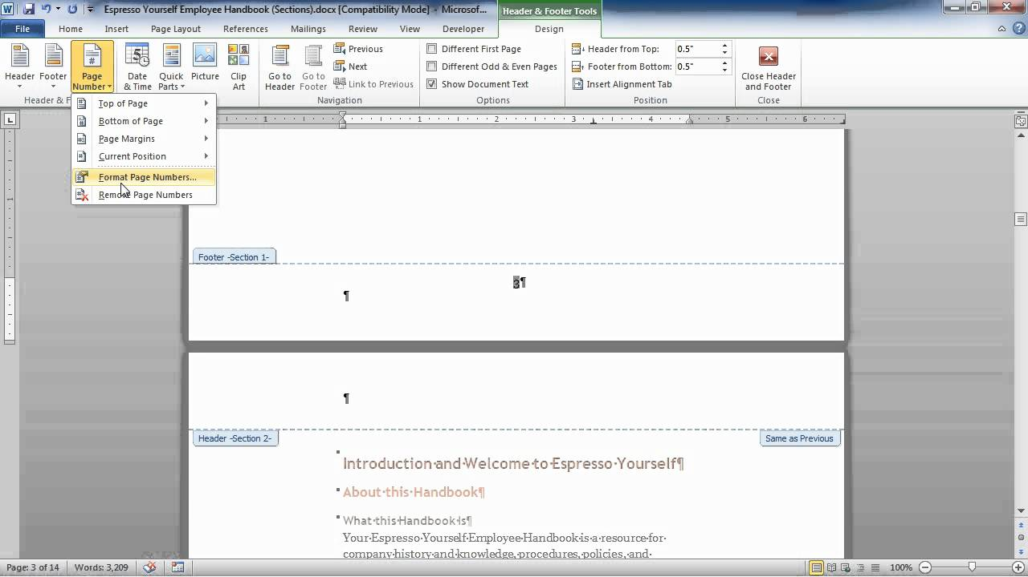Figure 7.Header

Figure 8.Foote

**Deleting:**

You can easily delete the text in Word including characters, paragraphs or all of the content of your document. Word offers you different methods to delete the text; some of the commonly used methods are given below;

* Place the cursor next to the text then press Backspace key.
* Place the cursor to the left of the text then press Delete key.
* Select the text and press the Backspace or Delete key.
* Select the text and type over it the new text.

**Moving:**

MS-Word is a word processing application that allows users to use its advanced feature for editing or creating files and documents in the best way. It is easy to use and learn. It is also very popular because of the vast features and tools provided by it to its user. Some of the commonly used methods are given below;

* First open MS-Word on your PC.
* Now, Open the document or create a new one in which you want to perform this operation.
* Now, Select the text you want to move.
* Now, click on the “**home tab**”
* Now, go to the “**Clipboard Section**” in the **home** tab.
* Now, In the “**Clipboard Section**” select the “**Cut**” option.
* Now, Put the cursor where you want the text to be placed. (anywhere as per your choice)
* Now, select the “**Paste**” option from the Clipboard section.
* So, the Selected text is successfully moved.

**Shortcut way:**

* As for moving text, we have used operations like cut and paste. So, there are shortcut keys for both cut-and-paste operations.
* The shortcut key for cut operation is **“Ctrl + X”**and the shortcut key for Paste operation is**“Ctrl + V”.**

**Replace:**

In Microsoft Word, the Replace feature lets u quickly find and replace text or formats in a document.

To replace text in Microsoft Word, you can use the Find and Replace feature:

* Go to the Home tab and select Replace
* In the Find what field, type the word or phrase you want to replace
* In the Replace with field, type the new text
* To replace all instances of the text, select Replace All
* To replace individual instances of the text, select Find Next to locate the text, and then select Replace
* To specify whether you want to search for upper or lowercase, select More > Match case
* When you're done, click Close or Cancel to close the dialog box.

**Editing a text in document:**  
There are many ways in Microsoft word from which you can edit your text document. Here are some of the following ways in which you can edit your document.

To edit text in Microsoft Word, you can add, replace, or format text:

* **Add text:** Place the cursor where you want to add text and type.
* **Replace text:** Select the text you want to replace, and type what you want. To select a word, double-click it. To select a line, click to the left of it.
* **Format text:** Select the text you want to format, and then use the options in the pop-up toolbar or the Home tab to change the font, font size, font color, or make the text bold, italic, or underlined. You can also copy the formatting and apply it to other text using the format painter.

**Saving a document:**

1. On the File tab, select Save As or Save a Copy.
2. In the Save dialog, select One Drive.
3. Update the name and file type if you want, and select save.
4. Select Browse, and navigate to any location including the Desktop.
5. Enter a name, and select Save.

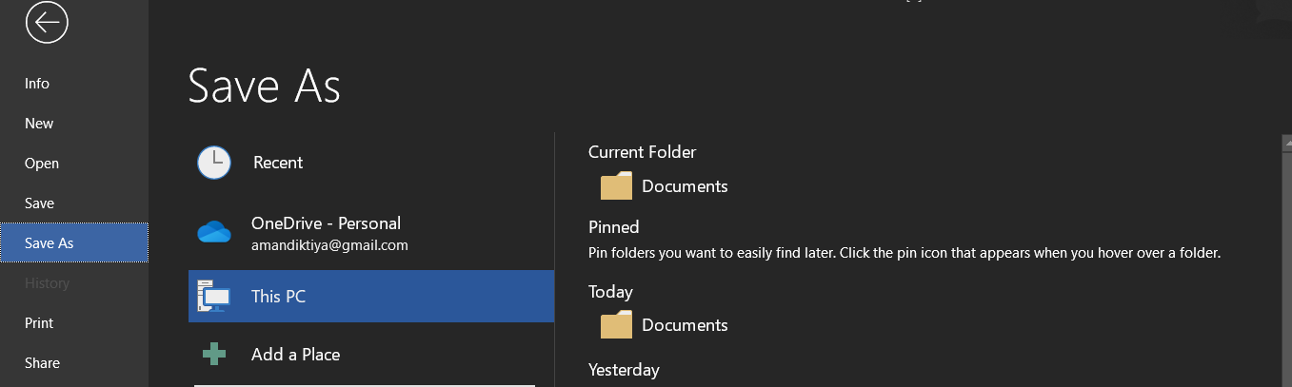

Figure 9.How to save

**Spellchecker:**

Microsoft Word has a special feature called spell check that allows you to check spelling and grammatical mistakes that you made in the document. Basically, spell check is a software tool that identifies the misspelled words present in the document. It also allows you to search a particular word in the document that you know you’ve misspelled in the whole document.

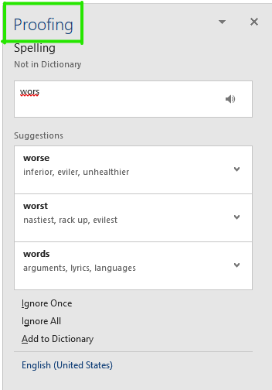

Figure 10.Spell Checker

**Printing a Document:**

1. Click the File menu and select Print.
2. Select your printer.
3. Choose which pages to print and the number of copies.
4. Click Print.

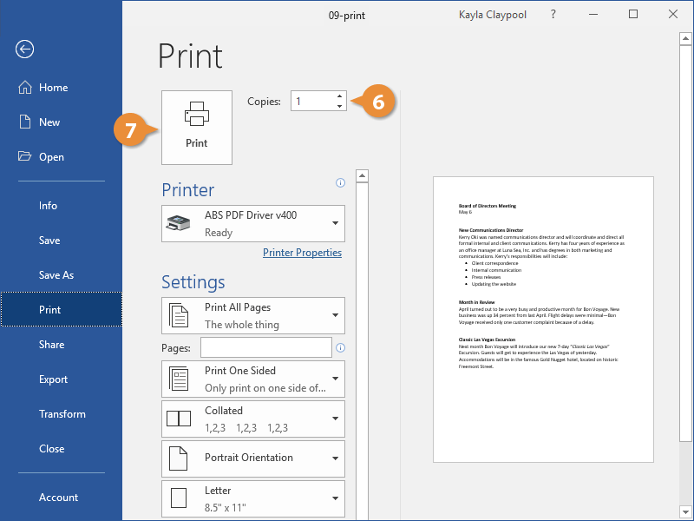

Figure 11. Printing a document

**Creating a table:**

In Word, you can insert a table, convert text into table, and even draw a table.

**Insert a table:**

To quickly insert a table:

Select **Insert>Table** and move the cursor over the grid until you highlight the number of columns and rows you want

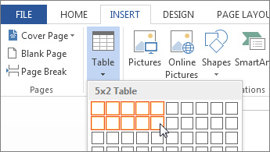

Figure 12.Table

For larger tables, or to customize the table:

1. Select **Insert** > **Table** > **Insert Table**.

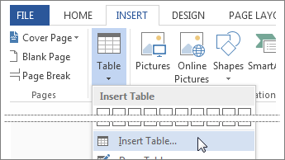

Figure 13.Inserting a table

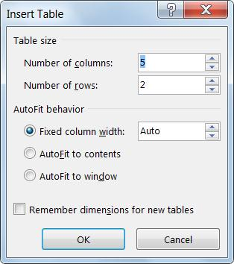2. Select the number of columns and rows, AutoFit behaviour, and then select **OK**.

**Entering and editing text in table:**

To enter text in table first select the row or column in which u want to want to enter text. Then enter the text which u wants to add in your tables. To edit it select or go to respectively in your row or column which you want to edit the text.

**Changing format of table:**

* Select a cell within your data.
* Select Home > Format as Table.
* Choose a style for your table.
* In the Create Table dialog box, set your cell range.
* Select OK.

**Changing height and width of row or column in table:**

To change height of table, take the following steps:

* Go in **INSERT** tab then from insert table option select the size of height and width of table in terms of row or columns or you can also distribute rows and distribute columns option in it.
* Like this you can edit both the height and width of all table.

**Borders:**

In Microsoft Word, a page border gives a border around the page or a border around the text on the page. Visit one of the links below for steps to create borders in Microsoft Word.

Steps to add borders in Word:

1. Open the Word document, where you want to add a border.
2. Go to the **Page Layout** tab and click on the **Page Borders** under the **Page Background**section.
3. A**Borders and Shading** window will appear on the screen.
4. Select the **Shadow** option to give shade around your page

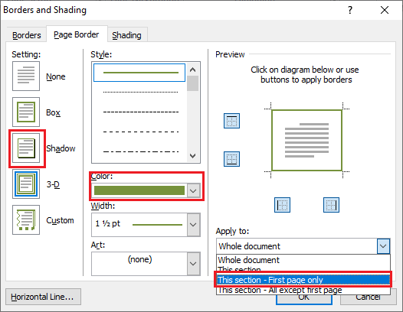

Figure 14.Borders

**Shading:**

Shading words or paragraphs gives them a background color that updates when you switch to a different document theme. It's different from highlighting text, which has a very limited choice of colours, and doesn't update when you switch to another theme. Select the word or paragraph that you want to apply shading to**.**

**Templates:** A template is a document type that creates a copy of itself when you open it. For example, a business plan is a common document that is written in Word. Instead of creating the structure of the business plan from scratch, you can use a template with predefined page layout, fonts, margins, and styles.

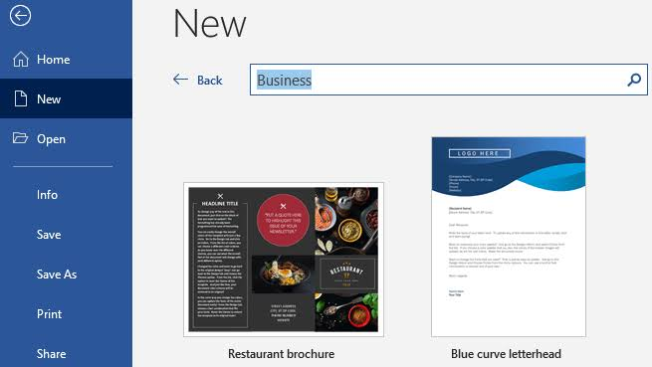

Figure 15.Templates

**Wizard:**

A wizardprompts you for information one step at a time and then generates a formatted document based on your answers. In this lesson, you will learn how to create a document using a template, create a template, and use wizardto create a document.

* On the Create tab, in the Forms group, click Form Wizard.
* Follow the directions on the pages of the Form Wizard.
* On the last page of the wizard, click Finish.

The Form Wizard can create a variety of results depending on the options that you select. As a result, we recommend that you run the wizard several times, experimenting with different options each time, until you get the results that you want.

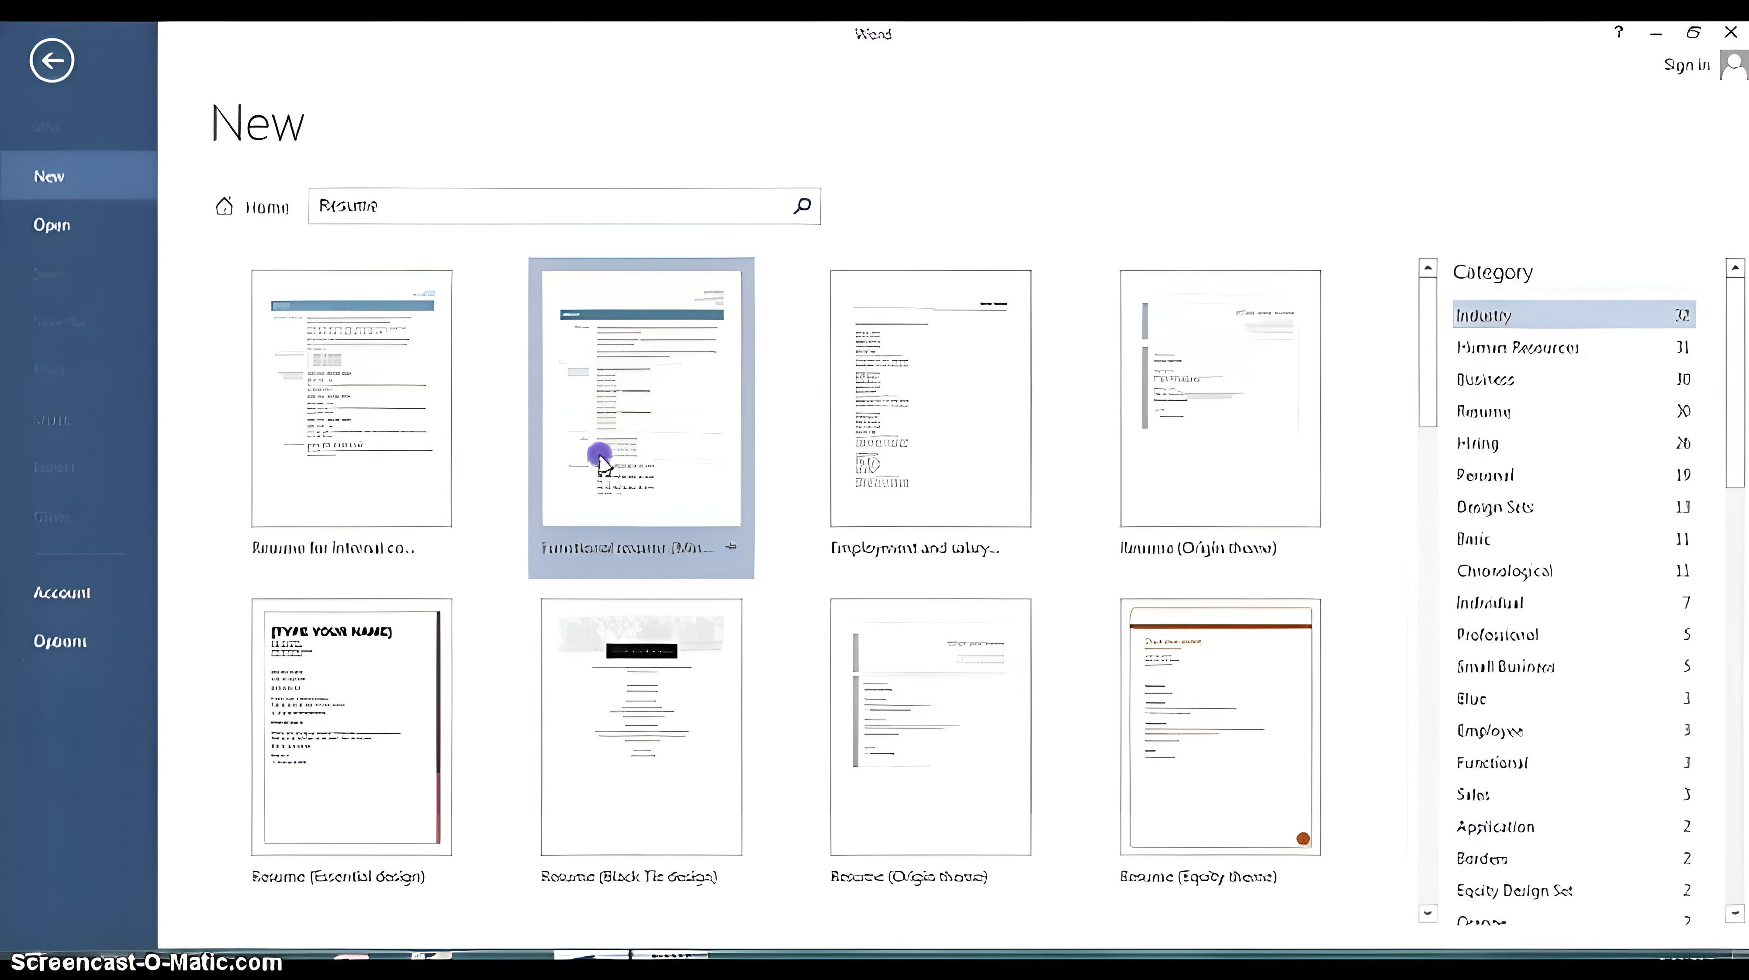

Figure 16. Wizard in letters

**Drawing objects:**

Drawing in Microsoft Word is a useful way to create images and edit text with a pen. You can use the drawing tool to add a personal element to your documents or create images that aren't easily available. If you work with Word to make documents in your professional or personal life, learning more about the drawing feature and how it works can be beneficial.

**These are the common steps you can follow to draw in Word:**

1. Open the Word document.
2. Locate and select the draw tab.
3. Choose your drawing tool.
4. Customize the drawing tool.
5. To edit text, choose the action pen.
6. Save and name your document.

**Mail Merge:**

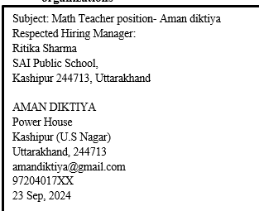Mail-Merge in Excelis a simple yet spectacular method used by analysts to write similar emails to hundreds or thousands of recipients without a hassle or even a single error. Mail-Merge in Excel is so proficient that it could even create an envelope (cover letter) for all yourmails using the same approach.

**Steps in mail merge:**

1. On the File tab, select New and choose Blank Document.
2. 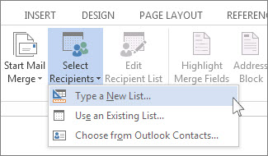On the Mailingstab, choose Select Recipients and select Type a New List.

3. In **the New Address List** dialog box type recipient information in each column as appropriate. For more info on using the dialog box, see Edit Data Source

4. For each new record, select b

5. If you need more columns, such as for an order number, follow these steps:

a. In the New Address List dialog box choose Customize Columns.

b.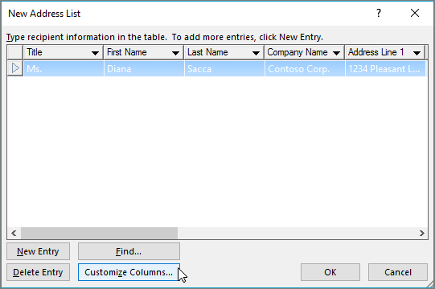

* 1. 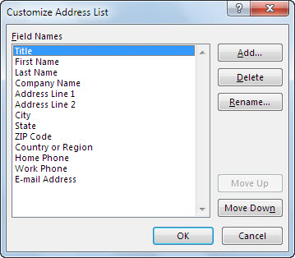Choose Add.
     1. Type a field name and then select OK.
     2. 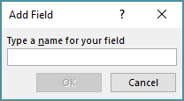
     3. Repeat steps b and c for each column or field to add.

7. When you're done adding all the people you want to your list, choose OK.

8. In the Save Address List dialog box, give your new file a name, and then chooseSave.

**Practical**

**A1.Create the following table and perform the operations given below**

**TIME TABLE**

|  |  |  |  |  |  |  |  |  |  |  |
| --- | --- | --- | --- | --- | --- | --- | --- | --- | --- | --- |
| Days | 1 | 2 | 3 | | 4 | LUNCH BREAK | 5 | 6 | 7 | 8 |
| **(10:00AM-10:50AM)** | **(10:50AM-11:40AM)** | **(11:40AM-12:30PM)** | | **12:30PM-1:20PM))** | **(1:40PM-2:30PM)** | **(2:30PM-3:20PM)** | **(3:20PM-4:10PM)** | **(4:10PM-5:00PM)** |
| Mon | DIGITAL TECH. | | PIC | | | PIC LAB | | | IOT |
| TUES | IOT | OA | DC | DIGITAL TECH. | | OA LAB | | | |
| WED | PIC lab | | IOT | | | DC | DC | IOT | IOT |
| THU | OA | DIGITAL TECH. | DC | | | CA | IOT | OA | OA |
| FRI | DIGITAL TECH. | | IOT | | | IOT | DC | OA | OA |
| SAT | C PROGRAMMING LAB | | | | | OA LAB | | | |

**A2. Create a standard covering letter and use mail merge to generate the customized letters for applying to a job in various organizations. Also, create a database and generate labels for the applying organizations**

Subject: Math’s Teacher position- Aman Diktiya

Respected Hiring Manager:

Amit Singh

K.V School,

Kashipur 244713, Uttarakhand

Aman diktiya

Power House

Kashipur (U.S Nagar)

Uttarakhand, 244713

amandiktiya@gmail.com

9420783XX

20 Sep, 2024

Respected Hiring Manager:

I am writing to express my interest in the Math’s Teacher Position at your School as advertised on naukri.com. With my background in B.Ed. from Shivalik Holy Mount Academy school. I am excited about the opportunity to contribute to your team.

My resume is attached. If I can provide you with any further information on my background and Qualifications, please let me know.

I am looking forward to hearing from you, Thank you for your consideration.

Sincerely,

Aman diktiya

Subject: Math Teacher position- Aman diktiya

Respected Hiring Manager:

Ritika Sharma

SAI Public School,

Kashipur 244713, Uttarakhand

AMAN DIKTIYA

Power House

Kashipur (U.S Nagar)

Uttarakhand, 244713

amandiktiya@gmail.com

97204017XX

23 Sep, 2024

Respected Hiring Manager:

I am writing to express my interest in the Math Teacher Position at your School as advertised on naukri.com. With my background in B.Ed. from. Shivalik Holy Mount Academy school. I am excited about the opportunity to contribute to your team.

My resume is attached. If I can provide you with any further information on my background and Qualifications, please let me know.

I am looking forward to hearing from you, Thank you for your consideration.

Sincerely,

Aman diktiya

Subject: Math’s Teacher position- Aman diktiya

Respected Hiring Manager:

Ajay Bisht

DAV international school,

Kashipur 244713, Uttarakhand

Aman diktiya

Power House

Kashipur (U.S Nagar)

Uttarakhand, 244713

amandiktiya@gmail.com

94203493XX

20 Sep, 2024

Respected Hiring Manager:

I am writing to express my interest in the Math’s Teacher Position at your School as advertised on

naukri.com. With my background in B.Ed. from Shivalik Holy Mount Academy school. I am excited about the opportunity to contribute to your team.

My resume is attached. If I can provide you with any further information on my background and Qualifications, please let me know.

I am looking forward to hearing from you, Thank you for your consideration.

Sincerely,

Aman diktiya

Subject: Math’s Teacher position- Aman diktiya

Respected Hiring Manager:

Garima Rawat

Hind Public School,

Kashipur 244713, Uttarakhand

Aman diktiya

Power House

Kashipur (U.S Nagar)

Uttarakhand, 244713

amanditiya@gmail.com

94205793XX

20 Sep, 2024

Respected Hiring Manager:

I am writing to express my interest in the Math’s Teacher Position at your School as advertised on naukri.com. With my background in B.Ed. from Shivalik Holy Mount Academy school. I am excited

about the opportunity to contribute to your team.

My resume is attached. If I can provide you with any further information on my background and Qualifications, please let me know.

I am looking forward to hearing from you, Thank you for your consideration.

Sincerely,

Aman diktiya

**DAILY NEWS LETTER**

* Semi-Conductor: -

They are used in many electronic devices, including diodes, transistors, and integrated circuits.

* This is an image of an integrated chip (IC) made up of semi-conductor. More information will be available on search engines.
* India’s is taking many steps in development of semi-conductor like: -The Programme for Development of Semiconductors and Display Manufacturing Ecosystem in India was notified with a total outlay of Rs. 76,000 crores**.**
* 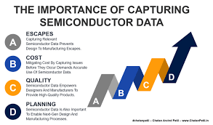The Union Cabinet had approved the proposal of Micron for setting up a **semiconductor unit** in**Sanand, Gujarat.**
* What is the Significance of Semiconductors?
* [Semiconductors](https://www.drishtiias.com/daily-news-editorials/india-s-semiconductor-mission) are essential to almost all sectors of the economy including aerospace, automobiles, communications, clean energy, information technology and medical devices etc.
* Demand for these critical components has outstripped supply, created a global chip shortage and resulted in lost growth and jobs in the economy. **Figure 2. Growth in this Sector**

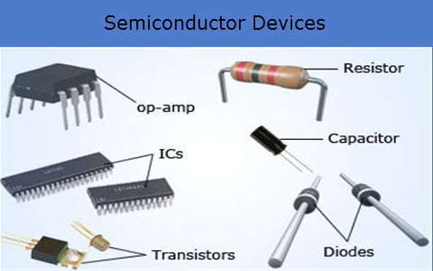

* In December 2021, the centre govt sanctioned ₹76,000 crore under the [Production-Linked Incentive (PLI)](https://www.drishtiias.com/daily-news-analysis/production-linked-incentive-pli-scheme-for-textiles-sector)scheme to encourage the manufacturing of various semiconductor goods within India.
* Semiconductors and displays are the foundation of modern electronics driving the next phase of digital transformation under[Industry 4.0](https://www.drishtiias.com/loksabha-rajyasabha-discussions/in-depth-industrial-revolution-4-0).

Figure 17.E.g. of semiconductor devices

* Now let’s not increase extend this now at last we will talk about the rise in this sector and how students have the opportunity to increase their knowledge and how they will get benefit in this field.
* A Counterpoint Research and the India Electronics & Semiconductor Association (IESA) report projects India’s semiconductor market to [value about $64 billion by 2026](https://www.business-standard.com/industry/news/india-s-semiconductor-market-to-touch-64-bn-by-2026-counterpoint-iesa-123051000216_1.html), showing three-times growth from

US$22.7 billion in 2019. Two-thirds of this market value will be created by the country’s telecom stack and industrial applications. Reporting in outputs puts India’s semiconductor market on course to be [worth US$80.3 billion by 2028](https://www.outlookindia.com/business/india-s-key-to-becoming-a-global-semiconductor-hub-skilled-manpower-in-semiconductor-manufacturing-news-272441).

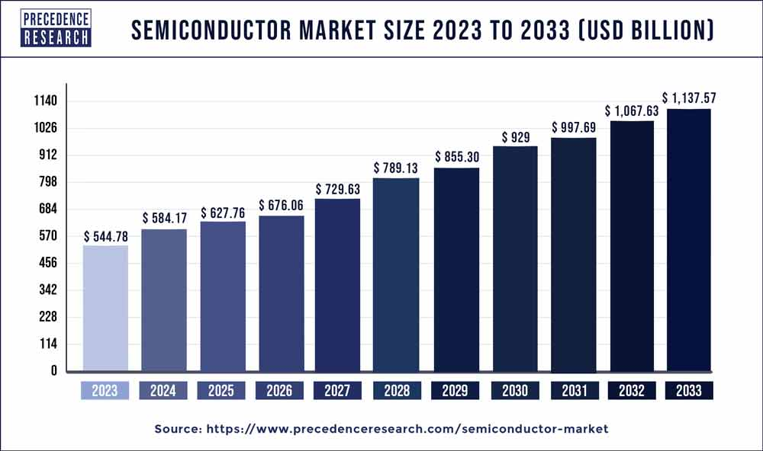

## Figure 3. Growth in this sector

The growth of the semiconductor industry involves several strategic steps across various dimensions. Here are some key areas to focus on:

**1. Investment in R&D**

* **Innovation:** Increase funding for research and development to foster new technologies, such as advanced materials, manufacturing techniques, and design processes.
* **Collaboration:** Partner with universities and research institutions to drive innovation.

**2. Infrastructure Development**

* **Manufacturing Facilities:** Build and upgrade fabrication plants (fabs) with cutting-edge technology to increase production capacity.
* **Supply Chain Resilience:** Strengthen the supply chain by diversifying suppliers and investing in logistics.

**3. Talent Acquisition and Development**

* **Workforce Training:** Invest in training programs to develop a skilled workforce, focusing on areas like engineering, design, and manufacturing.
* **Attract Talent:** Create initiatives to attract top talent globally, including internships and partnerships with educational institutions.

**4. Sustainability Initiatives**

* **Green Manufacturing:** Adopt eco-friendly practices in production to reduce environmental impact and comply with regulations

**DATE-**

**SPREADSHEET**

**Introduction:**

A **spreadsheet** is a computer application for computation, organization, analysis and storage of data in tabular form. Spreadsheets were developed as computerized analogs of paper accounting worksheets. It is the most popular application for accounting, analytics, data presentation, etc. In other words, spreadsheets are scalable grid-based files that are used to organize data and perform calculations.

**Example:**

**For example**– You may track data in a spreadsheet and see**sums, differences, multiplication, division, and fill dates**automatically, among other things.**Microsoft Excel, Google Sheets, Apache Open Office, LibreOffice, etc**. are some**spreadsheet software.**

**Workbook:**

A workbook is a spreadsheet program file that you create in Excel. A workbook contains one or more worksheets. A worksheet (also known as a spreadsheet) consists of cells in which you can enter and calculate data. The cells are organized into columns and rows. A worksheet is always stored in a workbook.

**Worksheets:**

A worksheet (also known as a spreadsheet) consists of cells in which you can enter and calculate data. The cells are organized into columns and rows. A worksheet is always stored in a workbook. A workbook can contain many worksheets. Think of it as a book.

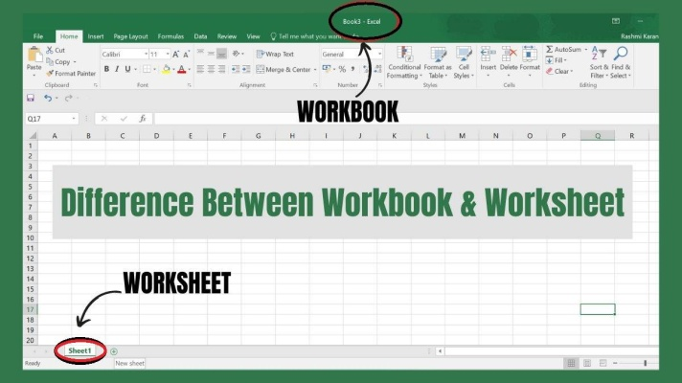

Figure 18. Worksheet and Workbook

**Wizards:**

The Chart Wizard is a spreadsheet feature that guides users through the process of creating charts and graphs. It provides a step-by-step interface to help user’s select data and chart types and customize various aspects of the chart's appearance depending on the selected data.

* Using Wizards: -

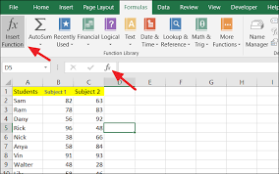The function wizard opens all of the functions in Excel, through sub-menus and categories. To use the Function Wizard, you can either choose Function from the Insert menu or you can click on the Function Wizard button "fx" located on the Standard toolbar.

Figure 19.Wizard

**Data type:**

In a Data Model, each column has an associated data type that specifies the type of data the column can hold: whole numbers, decimal numbers, text, monetary data, dates and times, and so on. Data type also determines what kinds of operations you can do on the column, and how much memory it takes to store the values in the column.

**Inserting, Removing, Resizing of Column & Rows:**

1.To insert a row or column

2.Click anywhere in the row below where you want to insert the new row.

3.Choose Insert.

4.Rows from the menu bar.

5.A new row is inserted above the cell(s) you originally selected

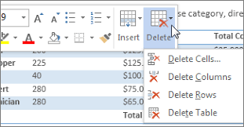

* **To remove a row or column:**

1.Right-click in a table cell, row, or column you want to delete.

2.On the Mini toolbar, click Delete.

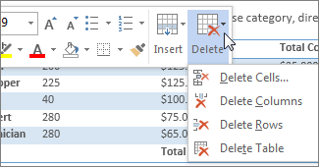3.Choose Delete Cells, Delete Columns, or Delete Rows.

* **To resizing a row or column:**

**Resize rows:**

1. Select a row or a range of rows.
2. On the **Home** tab, select **Format** > **Row Width** (or **Row Height**).
3. Type the row width and select **OK**.

**Resize columns:**

1. Select a column or a range of columns.
2. On the **Home** tab, select **Format** > **Column Width**(or **Column Height**).
3. Type the column width and select **OK**.

## Automatically resize all columns and rows to fit the data

1. Select the **Select All** button at the top of the worksheet, to select all columns and rows.

2. Double-click a boundary. All columns or rows resize to fit the data.

**Data & Ranges:**

A dataset is a range of contiguous cells on an Excel worksheet, which contain data to analyze. In a worksheet, cells with data on a spreadsheet would be a data set. However, a dataset doesn't really mean anything until you determine what it exists for and what kind of analysis needs to happen.

To select a data range, use the Go to feature as follows:

1. Click any cell in the data range. For instance, to select the data range A1:C9 (shown below) you could select any cell from A1 to C9.
2. Press [F5].
3. In the Go To dialog, click the Special button in the bottom-left corner.
4. In the resulting dialog, click the Current Region option.
5. Click OK, and Excel will select the current data range

In this context*,*currentregion means contiguous data, but the block of contiguous data can contain blanks. For instance, using the above data range, if there’s data in cell D10 and E7, this feature will include columns D and E and row 10 in the selection. Blank cells in the data range won’t matter. This feature makes selecting a data range easy, but there’s a keyboard shortcut that will do the same thing: [Ctrl] + [Shift] +8. If you do this often, it’s worth committing that keyboard shortcut to memory.

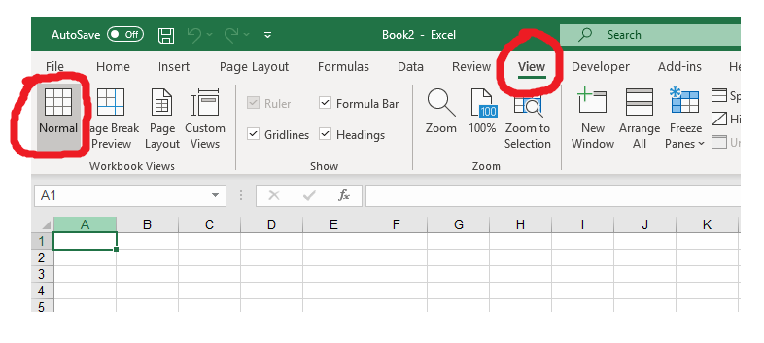**Different views:**

Microsoft excel offers 3 workbook view:

1. Normal.
2. Page Layout.
3. Page break view.

**Normal view**

At any time, you can switch back to normal view.

On the view tab, in the workbook views group, click Normal

**Page Layout view:**

Use Page layout view to see where pages begin and end, and to add headers and footers.

1. On the view tab, in the workbook views group, click page layout.

**Page Break View:**

Page Break view gives you a nice overview of where pages break when u print the document. Use this view to easily click and drag page break.

Figure20.Borders and Shading

1. On the view tab, in the workbook views group, click Page break preview.
2. 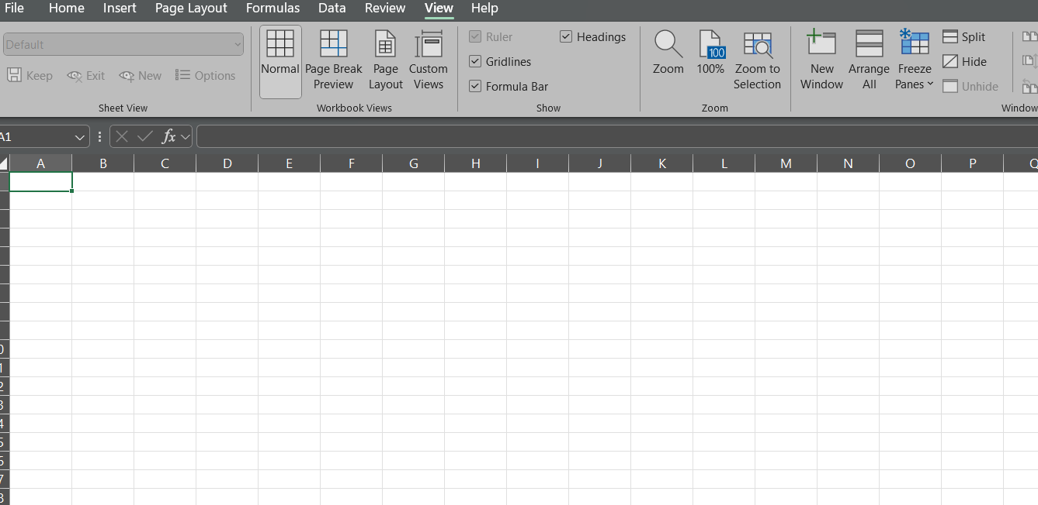Click page break Preview.

Figure 20 . Views in Workbook

**Freezing Rows and Column:**

First freeze the First Column

* 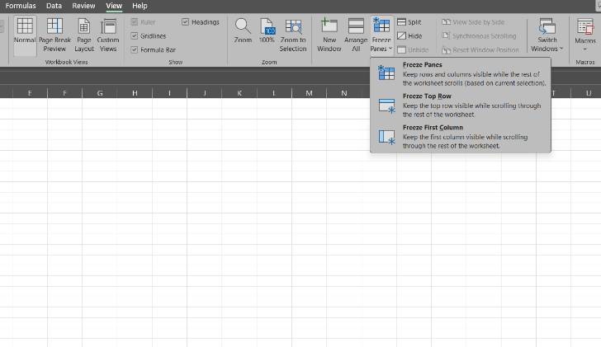Select > View > Freeze Panes >Freeze First Column. **(**The faint line that appears between Column A and B shows that the first column is frozen**).**

To Freeze first two Columns

* Select the third column.
* Select View > Freeze Panes

Freeze columns and rows

* Select the cell below the rows and to the right of the columns you want to keep visible when you scroll.
* Select View > Freeze Panes > Freeze Panes.

**LABELS:**

The term label usually refers to the text that u have typed in a cell. If the text appears next to a continuous list of values, Excel sees the label as a 'tag' that represents that range of values. The label can then be used in formulas instead of direct cell references.

**HIDE ROWS AND COLUMNS:**

To hide a row, follow the steps below.

* On the far-left side of the spreadsheet, right-click with your mouse on the row header for the row you want to hide.
* In the pop-up menu, select Hide
* Near the top of the spreadsheet, below the menu bar or Ribbon, right-click the column header for the column you want to hide.
* Select Hide in the pop-up menu.

**UNHIDE ROWS AND COLUMNS:**

## Unhide a row, follow the steps below

* 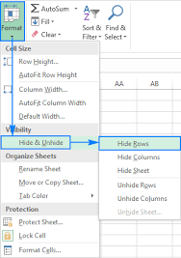Locate the hidden row; they are identified by looking for a missing number in the row headers. For example, the picture below shows row 1, row 2, row 3, row 5, and row 6. Row 4 is the hidden row, as it's missing in the row header numbering sequence.
* Using your mouse, select the column before and after the hidden column.
* Right-click the selected rows. In the pop-up menu, select Unhide.

Unhide a column, follow the steps below

* Locate the hidden column; they are identified by looking for a missing letter in the column headers. For example, the picture below shows column a, column C, and column D. With column B being the hidden column, as it's missing in the column header alphabetic naming sequence.
* Using your mouse, select the row above and below the hidden row.
* Right-click the selected columns. In the pop-up menu, select Unhide.

**Split cell:**

1. Select the cell or cells whose contents you want to split
2. Go to Data > Data Tools > Text to Columns.
3. Select the delimiter or delimiters to define the places where you want to split the cell content, and then select Apply.

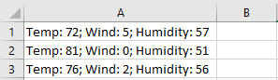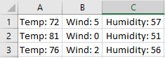

**Formulas & Functions:**

**Formulas:**

A formula in Excel is used to do mathematical calculations. Formulas always start with the equal sign (=) typed in the cell, followed by your calculation. Formulas can be used for calculations such as: =1+1. =2*2.

**Functions:**

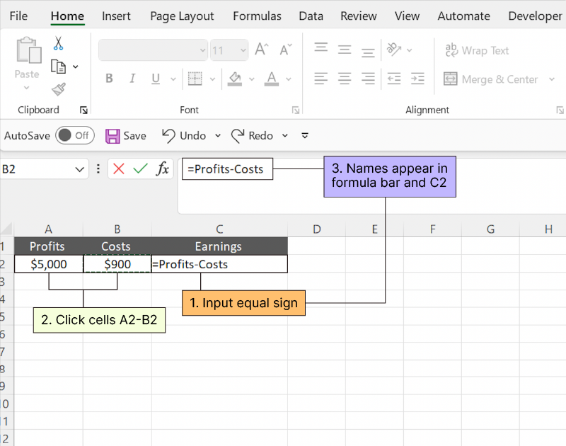Functions are predefined formulas that perform calculations by using specific values, called arguments, in a particular order, or structure. Functions can be used to perform simple or complex calculations. You can find all of Excel's functions on the Formulas tab on the Ribbon: Excel function syntax.

**Typing a formula inside a cell:**

1. Select a cell.
2. Type the equal sign =
3. Select a cell or type its address in the selected cell.
4. Enter an operator. For example, – for subtraction.
5. Select the next cell, or type its address in the selected cell.
6. Press Enter. The result of the calculation appears in the cell with the formula.

**Using insert function option from formula Tab**

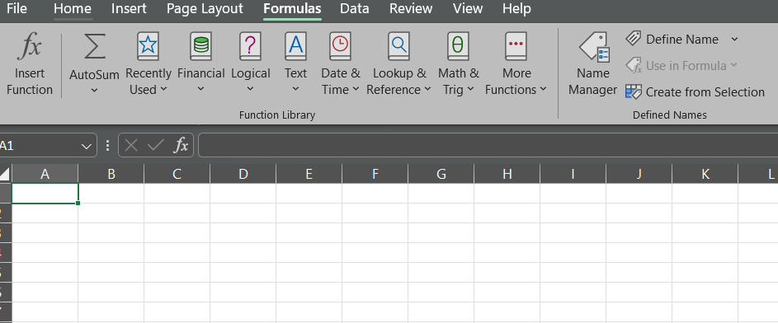If you're having trouble finding the right function, the Insert Function command lets you search for the function you want. It also guides you through inserting the arguments, which is helpful for complex functions. Click the cell where you want to add a formula. Click the Insert Function button.

**Quick insert: Use Recently Used tabs**

If you find re-typing your most recent formula a monotonous task, then use the Recently Used menu. It's on the Formulas tab, a third menu option just next

**Borders and Shading**

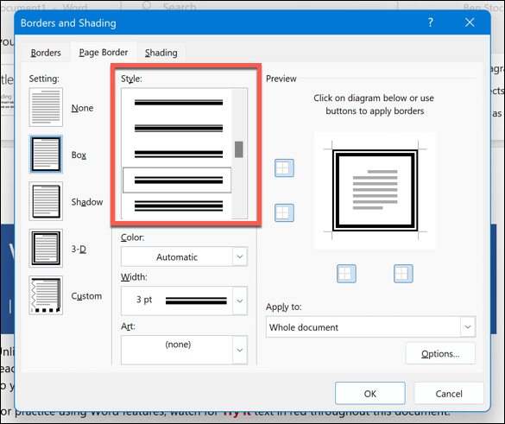Each worksheet contains several cells formed by the intersection of rows and columns. By default, the Excel cells have no borders and use white shades. However, borders or shades can help make data easy to read or highlight when we have a large data set.

Add border to a page:

* Go to Design > Page Borders.
* Make selections for how you want the border to look.
* To adjust the distance between the border and the edge of the page, select Options. Make your changes and select OK.
* Select OK.

From this tab you can select the tab you want for you Document. Then Click ok

**To apply shading:**

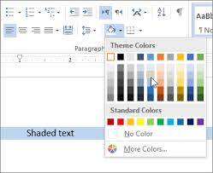You can apply shading using the Shading button in the Paragraph group on the Home tab. If you just click in a paragraph, the shading will be applied to the paragraph. If you select text first, the shading will be applied to the selected text.

**Steps to apply shading:**

1. Select the cells you want to change
2. On the Table Design tab (Table tab in OneNote), click the Shading menu
3. Under Theme Colour or Standard Colours, select the shading colour you want. Or, for more colour options, click More Colours. For more about on the Colours dialog box, see Choosing Colours in the Colours dialog box.

**Different Types of Charts in Excel:**

An Excel chart or graph is a visual representation of a Microsoft Excel worksheet's data. These graphs and charts allow you to see trends, make comparisons, pinpoint patterns, and glean insights from within the raw numbers. Excel includes countless options for charts and graphs, including bar, line, and pie charts

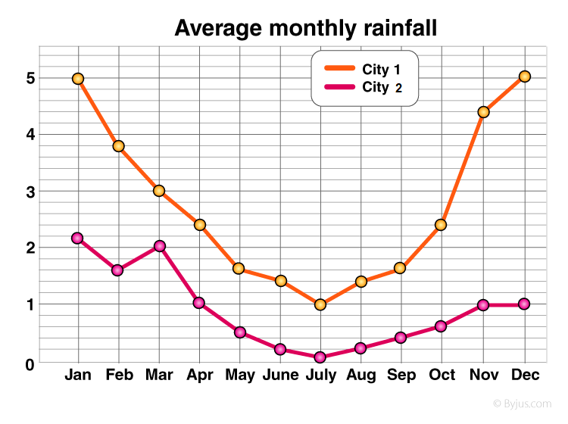**Column Chart:**

Data that is arranged in columns or rows on an Excel sheet can be plotted in a column chart. In column charts, categories are typically organized along the horizontal axis and values along the vertical axis.

**Column chart has the following major chart types:**

Clustered column chart Compares values across categories. A clustered column chart displays values in 2-D vertical rectangles. A clustered column in a 3-D chart displays the data by using a 3-D perspective.

Figure 21.Column chart

**Line chart:**

Line charts are graphical representations that succinctly illustrate trends and patterns in numerical data. For quantitative analysis, line charts excel in portraying continuous data over a specific period.

A line chart supports monitoring behaviour in a set of data. These charts are useful for more than tracking change over time. They also help highlight differences and correlations within your data.

**Line chart has the following major chart types:**

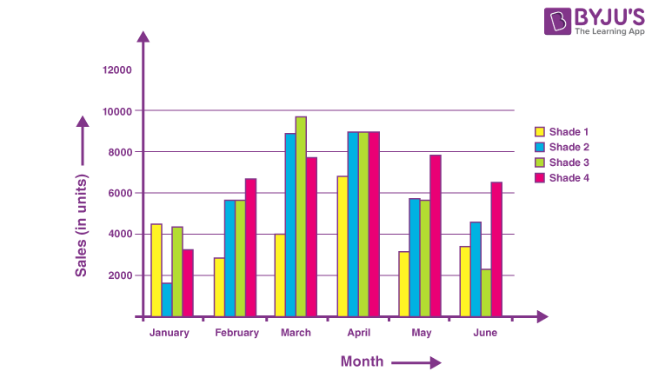Line stacked line, 100% stacked line with markers. Stacked line with markers 100% stacked line with markers 3-D line

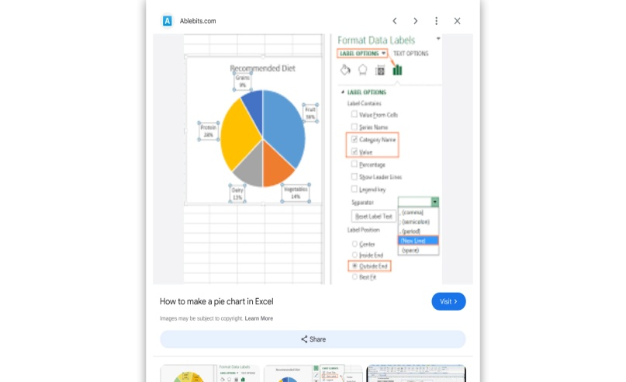**Pie chart:**

A pie chart is a tool to display basic statistical information, and is one of the easier charts to make in Excel. Follow these step-by-step instructions to master creating pie charts, along with tips for customizing the chart and variants you can use.

**A pie chart has following major sub types**:

3D pie chart and perspective pie cake, Doughnut chart, exploded pie chart, Polar area diagram, Ring Chart, Pie chart, Square.

**Printing Workbook and Worksheets:**

Print one or several worksheets

1. Select the worksheets that you want to print.
2. Select File > Print, or press CTRL+P.
3. Select the Print button or adjust Settings before you select the Print button.

### Print one or several workbooks

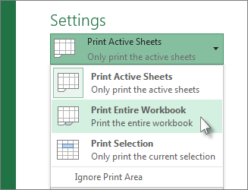All workbook files that you want to print must be in the same folder.

1. Select File > Open.
2. Hold down CTRL clicks the name of each workbook to print, and then select Print.

### Print all or part of a worksheet

1. Click the worksheet, and then select the range of data that you want to print.
2. Select File, and then click Print.
3. Under Settings, select the arrow next to Print Active Sheets and select the appropriate option.
4. Select Print.

DATE:

PRACTICAL: 05

**A4.** Create a result sheet containing Candidate's Register No., Name, Marks for six subjects. Calculate the total and result. The result must be calculated as below and failed candidates should be turned stored. Result is Distinction if Total >= 70 % First Class if Total > = 60 % and < 70 % Second Class if Total >= 50 % and < 60 % Pass if Total >= 35 % and < 50 % Fail otherwise Create a separate table based on class by using auto filter feature.

|  |  |  |  |  |  |  |  |  |  |
| --- | --- | --- | --- | --- | --- | --- | --- | --- | --- |
| **REG. No** | **NAME/SUB.** | **ENGLISH** | **HINDI** | **PHYSICS** | **CHEMISTRY** | **BIOLOGY** | **MARKS** | **TOTAL** | **RESULT** |
| 1020 | AMAN | 88 | 70 | 85 | 60 | 79 | 382 | 500 | **PASS** |
| 1021 | AMIT | 77 | 78 | 70 | 88 | 79 | 392 | 500 | **PASS** |
| 1022 | PRIYA | 85 | 88 | 81 | 79 | 70 | 403 | 500 | **PASS** |
| 1023 | ROHIT | 65 | 82 | 70 | 71 | 70 | 358 | 500 | **PASS** |
| 1024 | PAYAL | 50 | 40 | 25 | 25 | 22 | 162 | 500 | **FAIL** |

|  |  |  |  |  |  |  |  |  |
| --- | --- | --- | --- | --- | --- | --- | --- | --- |
| **GOVT POLYTECHNIC KASHIPUR** | | | |  | **GOVT POLYTECHNIC KASHIPUR** | | | |
| **NAME: AMAN** | | | | **NAME: AMIT** | | | |
| **BRANCH: IT** | | | | **BRANCH: IT** | | | |
| **REGISTER NO. : 1120** | | | | **REGISTER NO. : 1121** | | | |
| **SUBJECT** | **Marks** | **Total** | **Grade** | **SUBJECT** | **MARKS** | **TOTAL** | **GRADE** |
| English | 88 | 100 | DISTINCTION | English | 77 | 100 | FIRST |
| Hindi | 70 | 100 | DISTINCTION | Hindi | 78 | 100 | FIRST |
| Physics | 85 | 100 | DISTINCTION | Physics | 70 | 100 | FIRST |
| Chemistry | 60 | 100 | FIRST | Chemistry | 88 | 100 | FIRST |
| Biology | 79 | 100 | DISTINCTION | Biology | 79 | 100 | FIRST |
| TOTAL | 382 | 500 | DISTINCTION | TOTAL | 392 | 500 |  |
| **PERCENTAGE** | **76.40** |  |  | **PERCENTAGE** | **78.4** |  |  |

|  |  |  |  |  |  |  |  |  |
| --- | --- | --- | --- | --- | --- | --- | --- | --- |
| **GOVT POLYTECHNIC KASHIPUR** | | | |  | **GOVT POLYTECHNIC KASHIPUR** | | | |
| **NAME: PRIYA** | | | | NAME: ROHIT | | | |
| **BRANCH: IT** | | | | **BRANCH: IT** | | | |
| **REGISTER NO. : 1122** | | | | REGISTER NO. : 1123 | | | |
| **SUBJECT** | **Marks** | **Total** | **Grade** | **SUBJECT** | **Marks** | **Total** | **Grade** |
| English | 85 | 100 | A | English | 65 | 100 | FIRST |
| Hindi | 88 | 100 | A | Hindi | 82 | 100 | DISTINCTION |
| Physics | 81 | 100 | A | Physics | 70 | 100 | DISTINCTION |
| Chemistry | 79 | 100 | A | Chemistry | 71 | 100 | DISTINCTION |
| Biology | 70 | 100 | A | Biology | 70 | 100 | DISTINCTION |
| TOTAL | 403 | 500 |  | TOTAL | 358 | 500 |  |
| **PERCENTAGE** | 80.6 |  |  | **PERCENTAGE** | 71.6 |  |  |

|  |  |  |  |  |
| --- | --- | --- | --- | --- |
| **GOVT POLYTECHNIC KASHIPUR** | | | |  |
| **NAME : PAYAL** | | | |
| **BRANCH: IT** | | | |
| **REGISTER NO. 1124** | | | |
| **SUBJECT** | **MARKS** | **TOTAL** | **GRADE** |
| English | 50 | 100 | FIRST |
| Hindi | 40 | 100 | FIRST |
| Physics | 25 | 100 | FIRST |
| Chemistry | 25 | 100 | FIRST |
| Biology | 22 | 100 | DISTINCTION |
| TOTAL | 162 | 500 |  |
| **PERCENTAGE** | 32.4 |  |  |

**DATE:**

Practical: 06

**A5**. Create a table of records with columns as Name and Donation Amount. Donation amount should be formatted with two decimal places. There should be at least twenty records in the table. Create a conditional format to highlight the highest donation with blue color and lowest donation with red color. The table should have a heading

|  |  |  |  |  |  |
| --- | --- | --- | --- | --- | --- |
|  |  | **ANNUAL** | **DONATIONS** |  |  |
|  |  |  |  |  |  |
|  |  | **NAME** | **AMOUNT(RS)** |  |  |
|  |  | RITIKA | 734.57 |  |  |
|  |  | MAYANK RAWAT | 569.87 |  |  |
|  |  | PAYALG | 455.8 |  |  |
|  |  | MEGHA | 555.79 |  |  |
|  |  | JYOTI | 789.9 |  |  |
|  |  | SALONI | 341.09 |  |  |
|  |  | KAVITA | 590.1 |  |  |
|  |  | PINKI | 940.88 |  |  |
|  |  | SHIVANK | 1200.7 |  |  |
|  |  | ABHISHEK | 900.5 |  |  |
|  |  | AMAN | 450.56 |  |  |
|  |  | HIMANSHU | 990.24 |  |  |
|  |  | RAHUL | 690.66 |  |  |
|  |  | RAJAT | 910.44 |  |  |
|  |  | KRISHNA | 850.75 |  |  |
|  |  | GAURAV | 950.67 |  |  |
|  |  | LAKSHITA | 780.77 |  |  |
|  |  | AARTI | 2500.7 |  |  |
|  |  | DIYA | 5580.5 |  |  |
|  |  | DIKSHA | 10000.7 |  |  |
|  |  | DIMPLE | 21000.9 |  |  |

**DATE:**

**A6. Create line and bar chart to highlight the sales of the company for three different periods for the following data.**

|  |  |  |  |  |
| --- | --- | --- | --- | --- |
| Period | Product1 | Product2 | Product3 | Total |
| JAN | 35 | 40 | 50 | 125 |
| FEB | 46 | 56 | 40 | 142 |
| MAR | 70 | 50 | 40 | 160 |

**LINE CHART:**

**BAR CHART:**

**Date:**

**DATABASE**

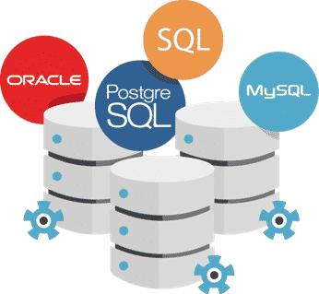A database is an electronically stored, systematic collection of data. It can contain any type of data, including words, numbers, images, videos, and files. You can use software called a database management system (DBMS) to store, retrieve, and edit data. In computer systems, the word database can also refer to any DBMS, to the database system, or to an application associated with the database.

Some examples of Databases:

* PostgreSQL
* MySQL
* Oracle Database
* SQL Server
* MongoDB

**Menus**

User can use Access macros to create custom shortcut menus that appear when right-clicked on forms, reports, or Individual controls. User can also create custom menus that appear on the Ribbon for specific forms or reports.

**Toolbar**

Toolbar contains a group of buttons that you can use to access forward engineering, reverse engineering, complete compare, select target server, and SQL validation dialogs

The Quick Access Toolbar (QAT) is a customizable toolbar containing a set of commands that are independent of the tab that is currently displayed. It can be located in one of two places: Upper-left corner above the ribbon (default location) Upper-left corner below the ribbon.

**Customize the Quick Access Toolbar**

1. Click the rightmost drop-down arrow in the toolbar.
2. Under Customize Quick Access Toolbar, click the required command that needs to be added.
3. Or, if the command is not listed, click More Commands, and proceed to the next step of this procedure.
4. In the Access Options dialog box, select the command or commands that needs to be added, and then click Add.
5. To remove a command, highlight it in the list on the right, and then click Remove.
6. Alternatively, double-click the command in the list.
7. Click OK.

**CREATE, EDIT & SAVE: Create a new blank database**

1. Start Access from the Start menu or from a shortcut.
2. The Backstage view appears.
3. Create a new web database
4. Under Available templates, click Blank web database.
5. On the right, under Blank web database, type a name for your database file in the File Name box or use
6. The one that is provided for you.
7. Click Create.
8. 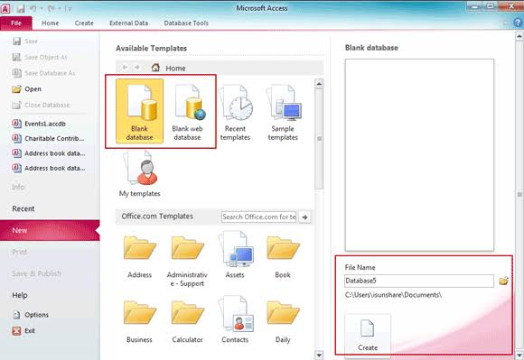The new database is created, and a new table is opened in Datasheet view

**Create a new desktop database**

1. Under Available templates, click Blank database.
2. On the right, under Blank database, type a name for your database file in the File Name box or use the one
3. That is provided for you.
4. Click Create.
5. The new database is created, and a new table is opened in Datasheet view

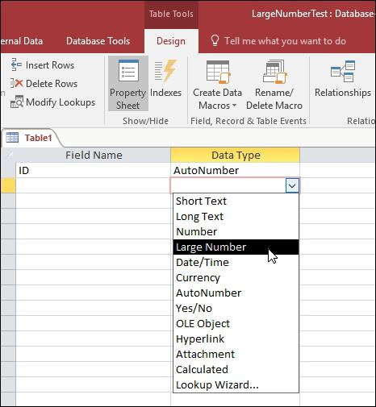**DATA TYPES:**

Every field in a table has properties and these properties define the field’s characteristics and behaviour. The most important property for a field is its data type. A field’s data type determines what kind of data it can store. MS Access supports different types of data, each with a specific purpose.

MS Access provides several data types – we will discuss Short Text, Long Text, Number, Large Number, Date/Time, Currency, AutoNumber, Yes/No, Calculated, and Lookup Wizard.

**INSERT**:

Any new data file which is required to appear in the database can be inserted from the New Data Source which appears under External Data tab. The user can choose the appropriate option for the file to be inserted from the appearing list of options under the New Data Source.

**DELETE:**

To Delete a record

The deletion process is fairly simple, except when the record is related to other data and resides on the “one” side of a one-to-many relationship. To maintain data integrity, by default, Access does not let you to Delete related data. For more information, see Guide to table relationships.

1. Open the table in Datasheet View or form in Form View.
2. To select a record, click the record selector next to the record, if the record selector is available. To extend or reduce the selection, drag the record selector (if it is available), or press SHIFT+DOWN ARROW or SHIFT+UP ARROW.
3. Press DELETE, select Home > Records > Delete, or press CTRL Minus Sign (-).

**UPDATE:**

An Update Query is an action query (SQL statement) that changes a set of records according to criteria (search Conditions) you specify. It’s a very powerful feature and a fundamental part of relational databases since you can Modify a huge number of records at one time. Understanding and using Update Queries improves the performance of your applications (versus doing the same changes manually or in code), and makes them easier to maintain.

The updated value can be:

1. The same value for all records
2. A value from another field in that table (updates the field based on a field’s value in its own record)
3. A value from a field in a linked table
4. An expression based on values in the table or linked tables (multiple fields can be used to calculate the new value)
5. A VBA function value which can include field values as its Parameters
6. Your own VBA user defined function that may or may not Include field values as parameters.

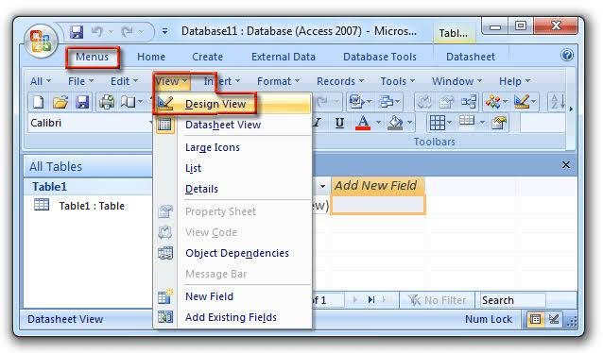**VIEW**:

Datasheet View shows the data in the database. It also allows you to enter and edit the data. It does not let you change the format of the database, other than minor changes (such as Displayed column widths). Design View allows you to create or change the table, form, or other database object, and configure the fields. You can also set keys and restrict the values entered here. But you can’t Change the database data in design view.

**SORT AND FILTER:**

You can sort Access data so you can view records in the order you want to view them, and you can filter data so you only see the records you want to see. This lesson teaches you how to sort and filter an Access table. Access data is stored in multiple tables

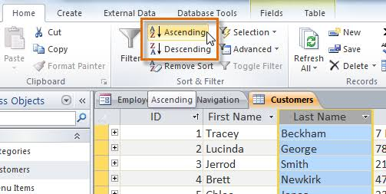To sort and filter in Microsoft Access, you can use the following features:

To sort records, you can:

* Click Advanced in the Sort & Filter group on the Home tab
* Click Advanced Filter/Sort from the shortcut menu
* Type an expression in the Field row
* Select Ascending or Descending in the Sort row

To filter records, you can:

* Click the drop-down arrow next to the field name
* 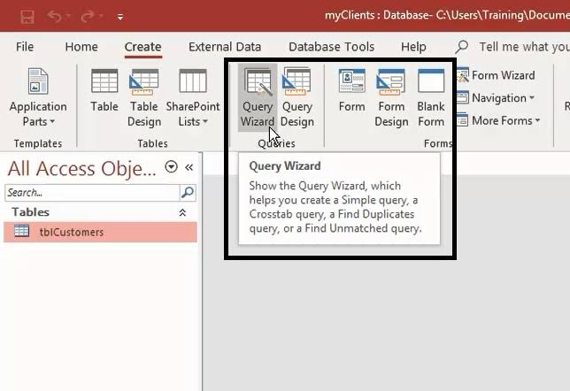Uncheck the values you don’t want to see
* Click Toggle Filter on the Home tab to turn the filter on or off

**Query:**

In Microsoft Access, a query is a database object that displays data from tables, or other queries, and makes the data available for use. Queries can be used for many purposes, including:

* Viewing data
* Adding, changing, or deleting data
* Summarizing and analysing data
* Finding matching, duplicate, or missing records
* Forming the basis of a report or query

**REPORT:**

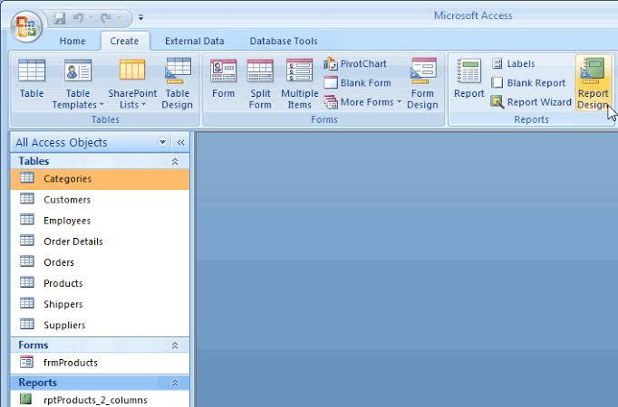Reports offer a way to view, format, and summarize the information in your Microsoft Access database. For example, you can create a simple report of phone numbers for all your contacts, or a summary report on the total sales across different regions and time periods. A report is a database object that comes in handy when you want to present the information in your database for any of the following uses:

* Display or distribute a summary of data.
* Archive snapshots of the data.
* Provide details about individual records.
* Create labels.

To create a report in Microsoft Access, you can follow these steps:

1. Open the table or query you want to use
2. Select the Create tab
3. Locate the Reports group, then click the Report command
4. Use the Report Wizard to add fields to your report:
5. Select the table or query that contains the fields you want on your report
6. Double-click fields in the Available Fields list to add them to the report
7. If you want to add fields from another table or query, click the Tables/Queries drop-down list again
8. Double-click the field you want to group by
9. Complete the rest of the wizard screens, and select Finish
10. Type a name for your report, then click OK

**PAGE SETUP**

Page Setup options help user fine tune the format with options for margin settings, use of gridlines and columns, or print only the data from the report without the formatting. To set the print page options, complete the following steps:

In the Navigation Pane, right-click the report and then click Print preview.

* On the Print Preview tab, in the Page Layout group,
* Click Page Setup and set the margins, orientation and column settings that user wants.

**PRINT**:

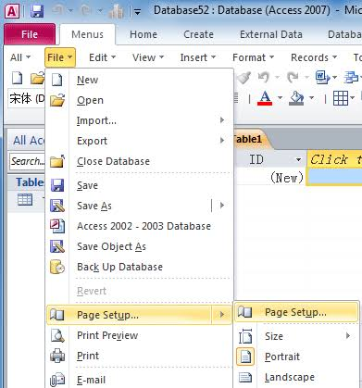After completing the page setup settings for a report, user can select specific printer options to control the print layout or the pages user wants printed and the number of copies.

In the Navigation Pane, right-click the report that is required to be printed, and click Print Preview.

* On the Print Preview tab, in the Print group, click Print.
* Keyboard shortcut Press CTRL P.
* Select your print options, and then click OK to print the report.
* The same procedure can be applied for any Database, File or a Record.

**DATE:**

**EXERCISE:**

**B1. Create Database to maintain at least 10 addresses of your class mates with the following constraints Roll no. should be the primary key. Name should be not null.**

|  |  |  |  |  |  |  |  |  |  |  |
| --- | --- | --- | --- | --- | --- | --- | --- | --- | --- | --- |
| STUDENT'S table | | | | | | | | | | |
| Serial Number | Registration Number | Name | DT | DDC | IOT | OS | PIC | TOTAL | PERCENTAGE | RESULT |
| 1 | 55566 | DHEERAJ MEHRA | 50 | 55 | 60 | 54 | 50 | 269 | 53.8 | SECOND CLASS |
| 2 | 55567 | NEERAJ DHANK | 65 | 52 | 65 | 55 | 54 | 291 | 58.2 | SECOND CLASS |
| 3 | 55568 | MOHIT PULAR | 50 | 54 | 58 | 59 | 67 | 288 | 57.6 | SECOND CLASS |
| 4 | 55569 | AMIT VERMA | 55 | 87 | 70 | 80 | 85 | 377 | 75.4 | DISTINCTION |
| 5 | 55570 | MAYANK RANA | 55 | 50 | 65 | 56 | 58 | 284 | 56.8 | SECOND CLASS |
| 6 | 55571 | KAPIL VERMA | 50 | 65 | 65 | 68 | 54 | 302 | 60.4 | FIRST CLASS |
| 7 | 55572 | KAMAL KOSYARI | 52 | 55 | 63 | 62 | 75 | 307 | 61.4 | FIRST CLASS |
| 8 | 55573 | PROMOD ALMIYA | 54 | 54 | 75 | 58 | 65 | 306 | 61.2 | FIRST CLASS |
| 9 | 55574 | PARAS KOHLI | 60 | 65 | 55 | 60 | 54 | 294 | 58.8 | SECOND CLASS |
| 10 | 55575 | VIVEK JOSHI | 65 | 60 | 54 | 53 | 58 | 290 | 58 | SECOND CLASS |

**B2. Create a student’s table with the following fields: Sr. No, Reg. No, Name, Marks in 5 subjects. Calculate total and percentage of 10 students. Perform the following queries.**

* **To find the details of distinction student**
* **To find the details of first-class students**
* **To find the details of second-class students Design a report for the above exercise to print the consolidated result sheet and mark card for the student**

**Distinction Query**

|  |  |  |  |  |  |  |  |  |  |
| --- | --- | --- | --- | --- | --- | --- | --- | --- | --- |
| DISTINCTION Query | | | | | | | | | |
| Registration Number | Name | DT | DC | IOT | OS | PIC | TOTAL | PERCENTAGE | RESULT |
| 55569 | AMIT VERMA | 55 | 87 | 70 | 80 | 85 | 377 | 75.4 | DISTINCTION |

**First Class Query:**

|  |  |  |  |  |  |  |  |  |  |
| --- | --- | --- | --- | --- | --- | --- | --- | --- | --- |
| FIRSTCLASS QUERY | | | | | | | | | |
| Reg. No. | Name | DT | DC | IOT | OS | PIC | TOTAL | PERCENTAGE | RESULT |
| 55571 | KAPIL  VERMA | 50 | 65 | 65 | 68 | 54 | 302 | 60.4 | FIRST CLASS |
| 55572 | KAMAL KOSHYARI | 52 | 55 | 63 | 62 | 75 | 307 | 61.4 | FIRST CLASS |
| 55573 | PROMOD ALMIYA | 54 | 54 | 75 | 58 | 65 | 306 | 61.2 | FIRST CLASS |

**Second Class Query:**

|  |  |  |  |  |  |  |  |  |  |
| --- | --- | --- | --- | --- | --- | --- | --- | --- | --- |
| SECONDCLASS QUERY | | | | | | | | | |
| Reg.NO, | Name | DT | DC | IOT | OS | PIC | TOTAL | PERCENTAGE | RESULT |
| 55566 | DHEERAJ MEHRA | 50 | 55 | 60 | 54 | 50 | 269 | 53.8 | SECOND CLASS |
| 55567 | NEERAJ DHANK | 65 | 52 | 65 | 55 | 54 | 291 | 58.2 | SECOND CLASS |
| 55568 | MOHIT PHULAR | 50 | 54 | 58 | 59 | 67 | 288 | 57.6 | SECOND CLASS |
| 55570 | MAYANK RANA | 55 | 50 | 65 | 56 | 58 | 284 | 56.8 | SECOND CLASS |
| 55574 | PARAS KOHLI | 60 | 65 | 55 | 60 | 54 | 294 | 58.8 | SECOND CLASS |
| 55575 | VIVEK JOSHI | 65 | 60 | 54 | 53 | 58 | 290 | 58 | SECOND CLASS |

**Design a report for the above exercise to print the consolidated result sheet and mark card for the student.**

|  |  |  |  |  |  |  |  |  |  |
| --- | --- | --- | --- | --- | --- | --- | --- | --- | --- |
| Registration Number | Name | DT | DC | IOT | OS | PIC | Total | Percentage | Result |
| 55566 | DHEERAJ MEHRA | 50 | 55 | 60 | 54 | 50 | 269 | 53.8 | Second class |
| 55567 | NEERAJ DHANK | 65 | 52 | 65 | 55 | 54 | 291 | 58.2 | Second class |
| 55568 | MOHIT | 50 | 54 | 58 | 59 | 67 | 288 | 57.6 | Second class |
| PULAR |
| 55569 | AMIT Verma | 55 | 87 | 70 | 80 | 85 | 377 | 75.4 | Distinction |
| 55570 | Mayank rana | 55 | 50 | 65 | 56 | 58 | 284 | 56.8 | Second class |
| 55571 | KAPIL VERMA | 50 | 65 | 65 | 68 | 54 | 302 | 60.4 | First class |
| 55572 | KAMAL KOSYARI | 52 | 55 | 63 | 62 | 75 | 307 | 61.4 | First class |
| 55573 | PROMOD ALMIYA | 54 | 54 | 75 | 58 | 65 | 306 | 61.2 | First class |
| 55574 | Paras Kohli | 60 | 65 | 55 | 60 | 54 | 294 | 58.8 | Second class |
| 55575 | Vivek Joshi | 65 | 60 | 54 | 53 | 58 | 290 | 58 | Second class |

**DATE:**

**PRESENTATION:**

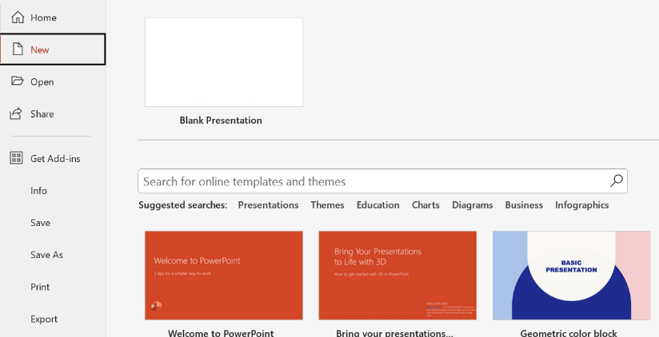A PowerPoint presentation is a visual tool used to present information, ideas, or data in a structured format through a series of slides. Created using Microsoft PowerPoint software, it is widely used in various settings, including business meetings, educational environments, conferences, and public speaking events. Some of the popular presentation products used across the globe are offered by Apple, Google and Microsoft. Microsoft PowerPoint is a professional presentation program that allows the user to create "presentation slides" that can be displayed on the computer screen or through a projector that is plugged into the computer. A PowerPoint presentation is a good way to convey pieces of information, usually in the form of an outline, to a large audience. Generally, PowerPoint presentations are appealing to users because they are easy to create and edit and generally small enough to fit onto a CD or a USB Jump Drive. Therefore, a user does not have to carry around any slides or slide projector, and, if necessary, can make any last-minute changes to the presentation.

**Steps to open a new presentation**

Create a New Presentation:

* Select the File tab to go to Backstage view.
* Select New on the left side of the window, then click Blank Presentation.
* A new presentation will appear.

**Steps to open an existing presentation:**

* In addition to creating new presentations, one will often need to open a presentation that was previously saved.
* Select the File tab to go to Backstage view, then click Open.
* Click Browse. Alternatively, you can choose OneDrive to open files stored on your OneDrive.

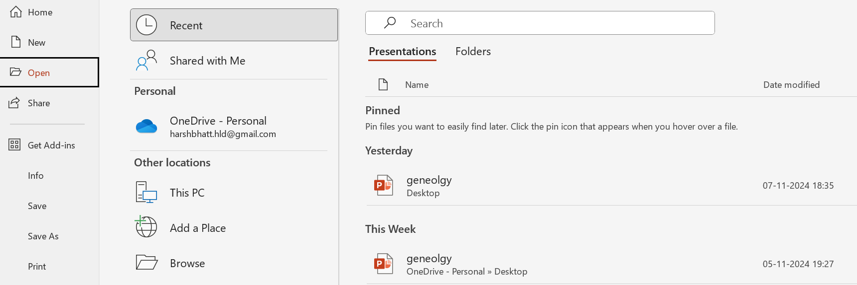

* The Open dialog box will appear. Locate and select your presentation, then click Open.

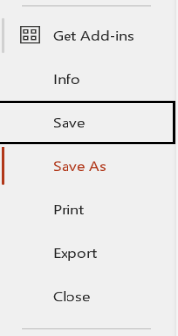**Steps to save a presentation:**

* Select Office button> Save. The Save As dialog box appears. Most of the time, when you're ready to save your presentation, you'll choose the .pptx file type or .ppt. But you have got about a dozen choices, including the template **(.potx)** and show **(.ppsx)** formats.

You can press **Ctrl+S** or click the Save button that appears in the Quick Access toolbar.

* 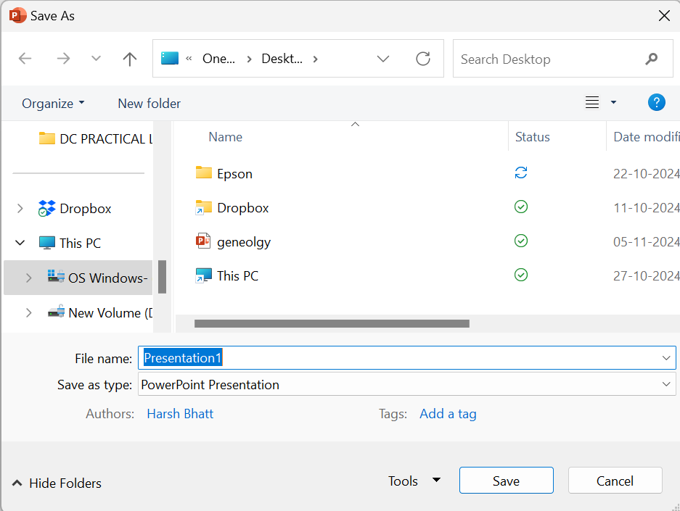Click the Save in drop-down box to choose a directory to store your file in. In the File name field, type a new name for your file.
* Click the Save as Type drop-down box to select a file format. Most of the time, you will choose the .pptx format and click Save. The Save As dialog box disappears and PowerPoint saves the file in the format you specified.

**FEATURES OF PRESENTATION:**

**Background Design:**

The background is the graphic that fills the space behind the content that's the focus on the slide. It may be a design, colour, picture, or a combination of these visual elements. Initially, there's only a plain white background on a PowerPoint slide. You can place images, adjust the colours, or leave it as is to complement the information that you're trying to communicate with your text.

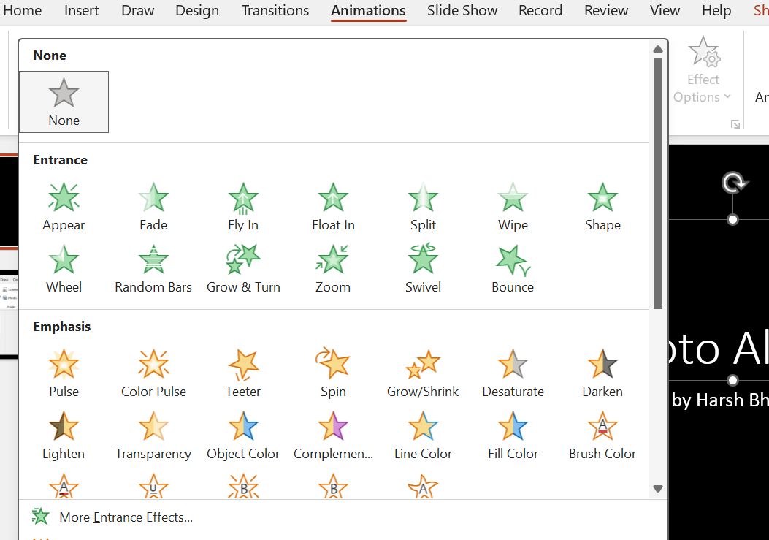The main purpose of a PowerPoint presentation is to help the presenter relay information effectively. Making it interesting can be important to keep the audience focused and interested in the topic. Changing the background of a PowerPoint slide to improve its appearance and complement the content of the presentation can be a good way to achieve this.

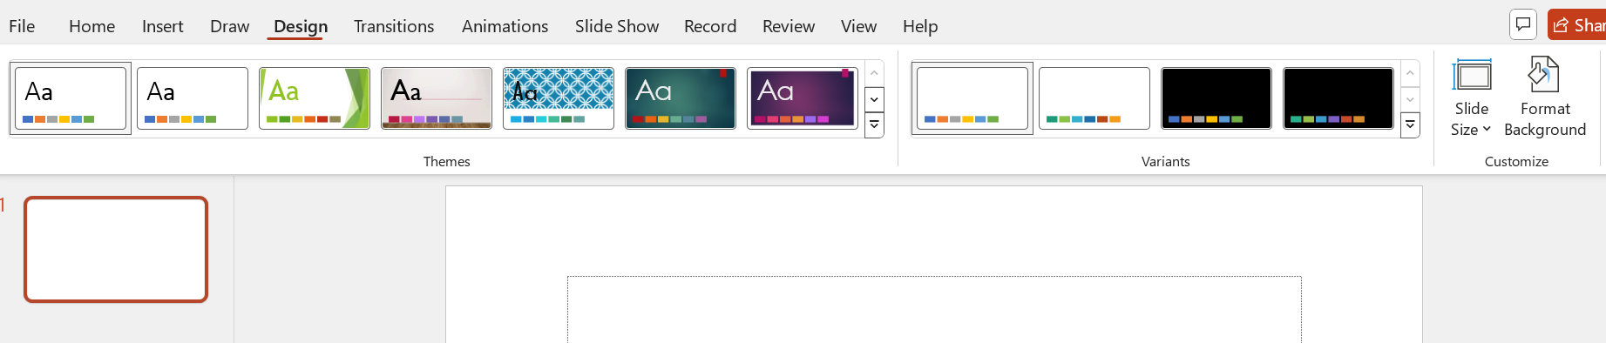

**Word ART:**

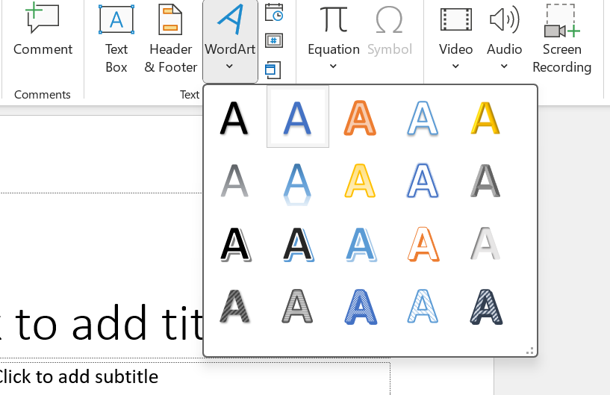WordArt is a gallery of text styles that you can add to your publications to create decorative effects, such as shadowed or mirrored (reflected) text. You can use WordArt to add special text effects to your document

For example, you can stretch a title, skew text, make text fit a preset shape, or apply a gradient fill.

**Clip ART:**

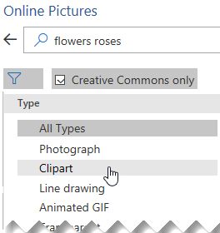Clipart is a graphic art which is generally found in electronic form. Clipart is composed by hand or by some kind of computer software

Clip art is a type of digital picture that is used for a variety of graphic design projects. Images that are added to Microsoft Word documents, brochures, and other materials are among the most common types of clip art that are known to most basic computer users.

**Drawing:**

Draw a Shape Using the Scribble Tool.

* Select Insert > Shapes.
* To draw a scribbled shape, select the Scribble icon.
* Hold down your mouse or trackpad to draw a scribble in your PowerPoint slide. The ends don't have to connect. Once completed, the Format section will appear. Use this section to change the design of your shape.

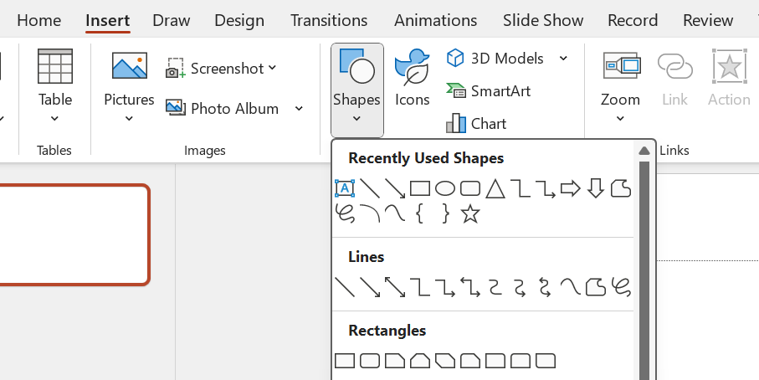

**3D SETTINGS**:

**Animations:**

User can animate the text, pictures, shapes, tables, SmartArt graphics, and other objects in your PowerPoint presentation. Effects can make an object appear, disappear, or move. They can change an object's size or color.

* Select Animations and choose an animation.
* Select Effect Select the object or text you want to animate.
* Options and choose an effect.

After the successful application of animation and its effects in respective slide the results can be previewed to check how are the effects going to look while presentation & as per the user’s choice the same can also be formatted later.

**Sounds:**

PowerPoint allows you to add audio to your presentation. For example, you could add background music to one slide, a sound effect to another, and even record your own narration or commentary. You can then edit the audio to customize it for your presentation.

User may select desired sounds under Timing bar for the required animation from the Transitions tab.

**Views:**

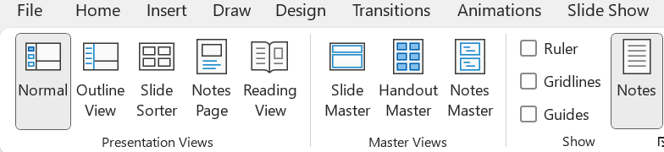PowerPoint has a number of different views to work with when working on your presentation. Each view represents one way to look at your presentation, and each provides different options to manage or edit one or more slides. The different views are Normal, Outline, Slide Sorter, Notes, and Reading.

**Normal View:**

You can get to Normal view from the task bar at the bottom of the slide window, or from the View tab on the ribbon. Normal view is the editing mode where you’ll work most frequently to create your slides. Below, Normal view displays slide thumbnails on the left, a large window showing the current slide, and a section below the current slide where you can type your speaker notes for that slide.

**Slide Sorter View:**

You can get to Slide Sorter view from the task bar at the bottom of the slide window, or from the View tab on the ribbon. Slide Sorter view (below) displays all the slides in your presentation in horizontally sequenced, thumbnails. Slide show view is helpful if you need to reorganize your slides— you can just click and drag your slides to a new location, or add sections to organize your slides into meaningful groups.

**Notes Page View:**

User can show or hide your speakers notes with the Notes button notes button in PowerPoint at the bottom of the slide window, or you can get to Notes Page view from the View tab on the ribbon. The Notes pane is located beneath the slide window. You can print your notes or include the notes in a presentation that you send to the audience, or just use them as cues for yourself while you're presenting. Notes Thumbnails Notes 41

**Outline View:**

User can get to Outline view from the View tab on the ribbon. Use Outline view to create an outline or story board for your presentation. It displays only the text on your slides, not pictures or other graphical items.

**Reading View:**

You can get to Reading view from the task bar at the bottom of the slide window. Most people reviewing a PowerPoint presentation without a presenter will want to use Reading view. It displays the presentation in a full screen like Slide Show view, and it includes a few simple controls to make it easy to flip through the slides.

**Master View**:

To get to a master view, on the View tab, in the Master Views group, choose the master view that one wants. Master views include, Slide, Handout, and Notes. The key benefit to working in a master view is that user can make universal style changes to every slide, notes page, or handout associated with the presentation.

**Inserting a Slide:**

* Insert > New Slide Or just pressing CTRL M inserts a new slide into the Presentation.

**Deleting a Slide:**

* For a single slide: Right-click the slide in the thumbnail pane on the left, and select Delete Slide.
* For multiple slides: Press and hold Ctrl, and in the thumbnail pane on the left, select the slides. Release the Ctrl key. Then right-click the selection and choose Delete Slide.
* For a sequence of slides: Press and hold Shift, and in the thumbnail pane on the left, select the first and last slides in the sequence. Release the Shift key. Then right-click the selection and choose Delete Slide.

Rearrange the order of slides In the pane on the left, click the thumbnail of the slide that you want to move, and then drag it to the new location. To select multiple slides: Press and hold Ctrl, and in the pane on the left, click each slide that you want to move. Release the Ctrl key, and then drag the selected slides as a group to the new location. Slide being dragged to the top

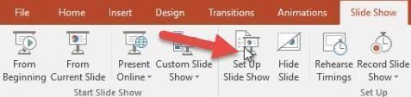**SLIDES SHOW:**

Setup Show Set the slideshow to loop continuously

Go to Slide Show > Set Up Show

Turn on “Loop continuously until ‘Esc’”, then click “OK”.

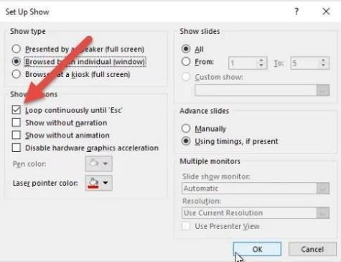**Rehearsal:**

User can rehearse a presentation to make sure that it fits within a certain time frame. While user rehearses, use the Slide Timing feature to record the time that you need to present each slide, and then use the recorded times to advance the slides automatically when you give your presentation to your actual audience. The Slide Timing feature is ideal for creating a self-running presentation. On the SLIDE SHOW tab, in the Set Up group, click Rehearse Timings.

* The Rehearsal toolbar appears, and the Slide Time box begins timing the presentation.
* 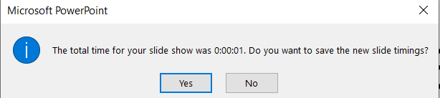While you time your presentation, do one or more of the following on the Rehearsal toolbar: • To move to the next slide, click Next.
* To temporarily stop recording the time, click Pause.
* To restart recording the time after pausing, click Pause.
* To restart recording the time for the current slide, click Repeat. After you set the time for the last slide, a message box displays the total time for the presentation and prompts you to do one of the following:
* To keep the recorded slide timings, click Yes.
* To discard the recorded slide timings, click No. Slide Sorter view appears and displays the time of each slide in your presentation.

**Custom Show:**

When you create a custom show in PowerPoint, you can adapt a presentation for different audiences. Use a custom show to present only certain slides from your presentation, or to create a hyperlink to a group of slides in your presentation.

Creating Custom Presentations.

* Go to Slide Show > Custom Slide Show, and then select Custom Shows.
* In the Custom Shows dialog box, select New.
* Under Slides in presentation, choose the slides that you want to include in the custom show, and then select Add.
* To change the order in which slides appear, under Slides in custom show, select a slide, and then click one of the arrows to move the slide up or down in the list.
* Type a name in the Slide show name box, and then click OK.

**ACTION SETTING:**

Use an Action button to do an action in your presentation, such as going to the next or a specific slide, running an app, or playing a video clip. There are two basic steps for setting up an Action button: First, you pick an action button from the Shapes gallery Then you assign an action that occurs when (during Slide Show) you click the shape or point the mouse at it. The idea is that when you deliver your presentation, you can click or point at an action button to: Go to the next slide, the previous slide, the first slide, the last slide, the most recent slide viewed, a specific slide number, a different PowerPoint presentation, or a Web page. Run a program Run a macro Play an audio clip.

**Put an action button on your slide**

Some examples of built-in action button shapes in the Shapes gallery include right and left arrows (commonly understood symbols for going to next, previous, first, and last slides), for playing videos or sound bites, and more.

On the Insert tab, click Shapes, and then under Action Buttons at the bottom of the menu, click the button shape that you want to add. Click a location on the slide, and then drag to draw the shape for the button. Keep the dialog box open and go to the next procedure.

**Assign an action**

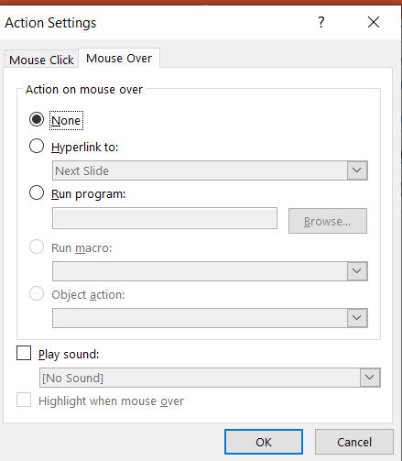

If you want the action to occur when the action button is clicked, do the following steps on the Mouse Click tab of the dialog box. If you want the action to occur when the action button is simply pointed at, do the following steps on the Mouse Over tab of the dialog box.

To choose the action that takes place when you click or move the pointer over the action button, do one of the following:

* Choose Hyperlink to and then select the destination (for example, the next slide, the previous slide, the last slide, or another PowerPoint presentation) that you want the hyperlink action to go to.
* Note: To link to a file created by another program, such as a Word or Excel file, in the Hyperlink to list, click Other File.
* Choose None to use the shape without a corresponding action.
* Choose Run program, then click Browse to locate the program that you want to run.
* Choose Run macro and then select the macro that you want to run.
* The Run macro settings are only available if your presentation already contains a macro, and when you save the presentation, you must save it as a PowerPoint Macro- enabled Show.

The Object action settings are only available if your presentation contains an OLE object. To play a sound, select the Play sound check box, and then select the sound that you want to play. When you've finished choosing your action, select OK. To test the action you've selected, choose Slide Show > From Current Slide to open the presentation in Slide Show so that you can click the action button.

**WORKING WITH AUTO CONTENT WIZARD:**

PowerPoint's AutoContent Wizard (Ver. 2016) gives you a head start on setting up a presentation based on various prefab templates. But user can also plug their own presentations into the wizard, making it easy to reuse their design, structure, and content.

Steps to add an existing presentation:

* Launch the wizard by choosing New from the File menu.
* Click the From AutoContent Wizard link in the New Presentation task pane.
* Click Next in the wizard's first pane.
* Choose the most appropriate content template category from the list and click Add. The presentation added is now available to use as a template when you run the AutoContent Wizard.

**DATE:**

### EXERCISE:

**B3. Make a marketing presentation of any consumer product with at least 10 slides.**

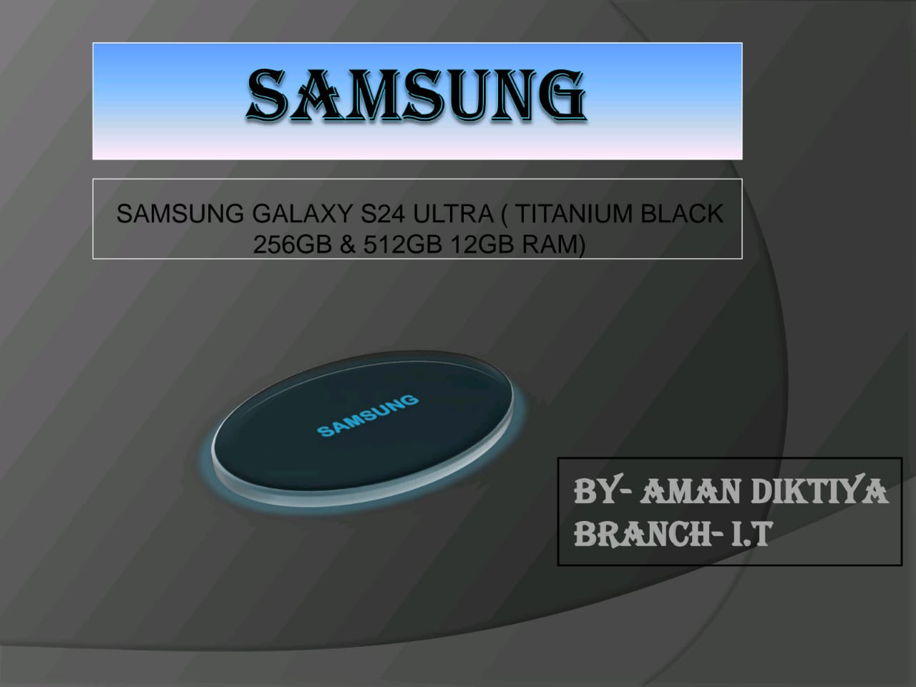

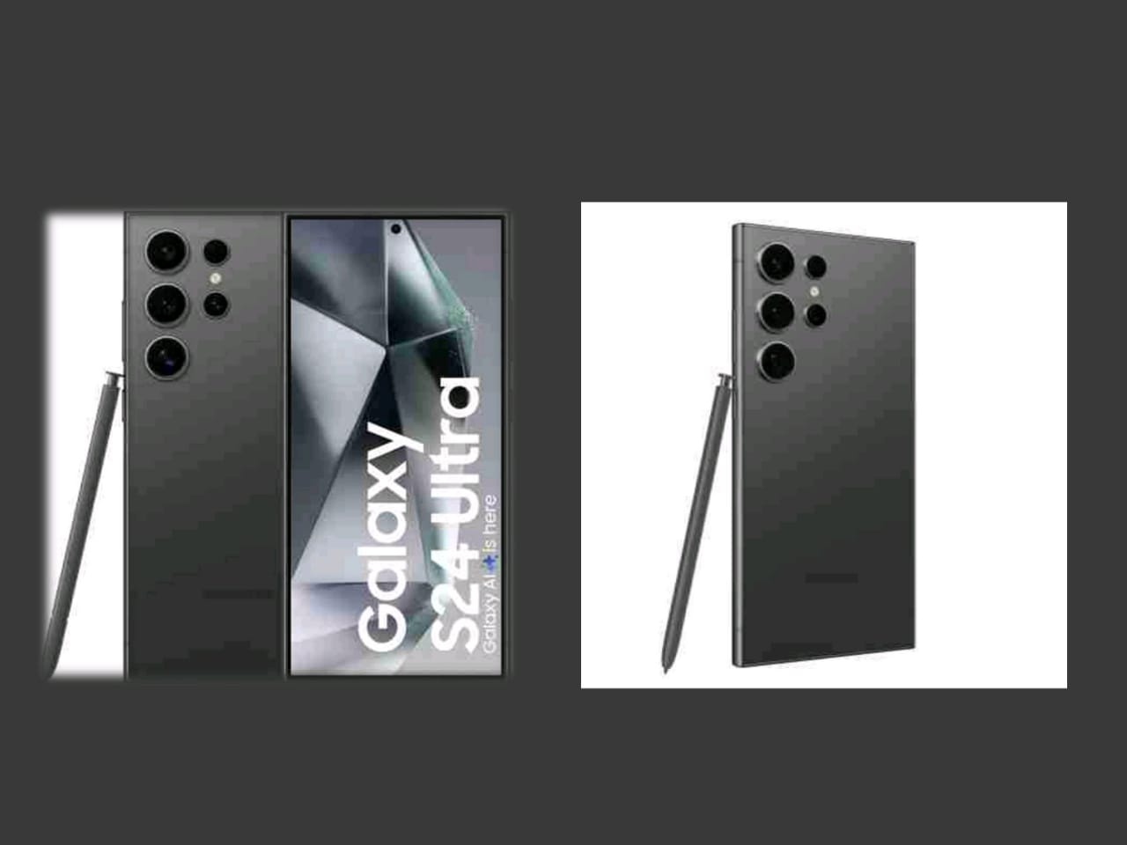

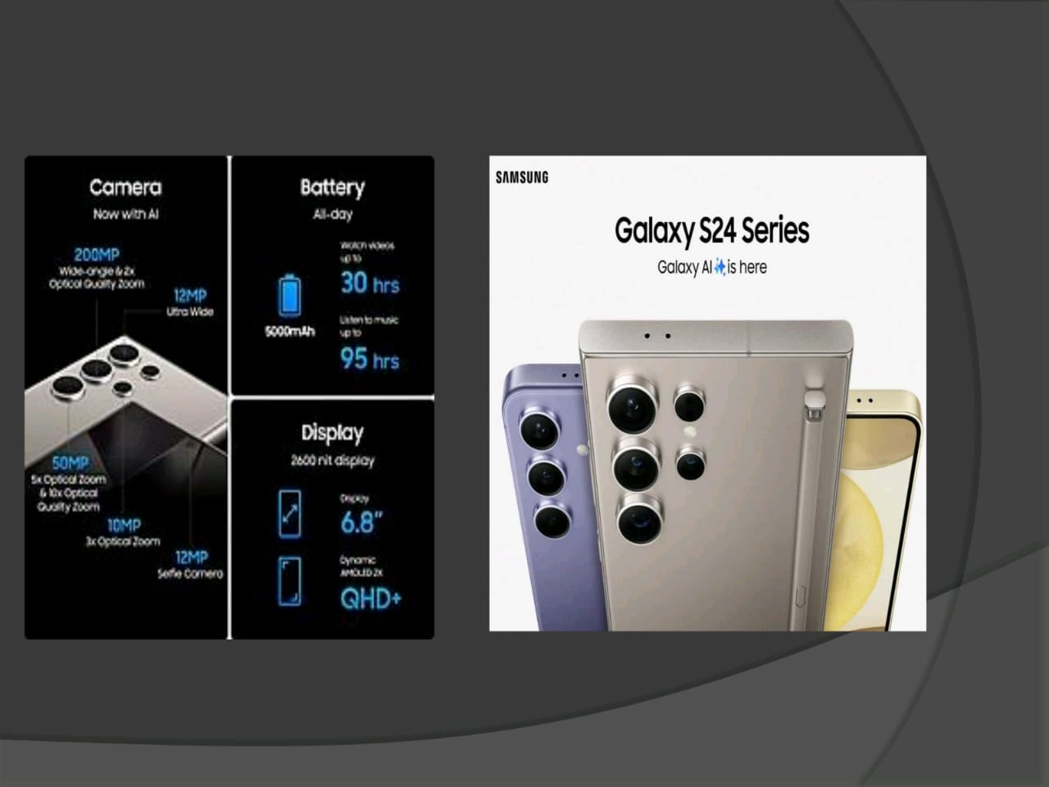

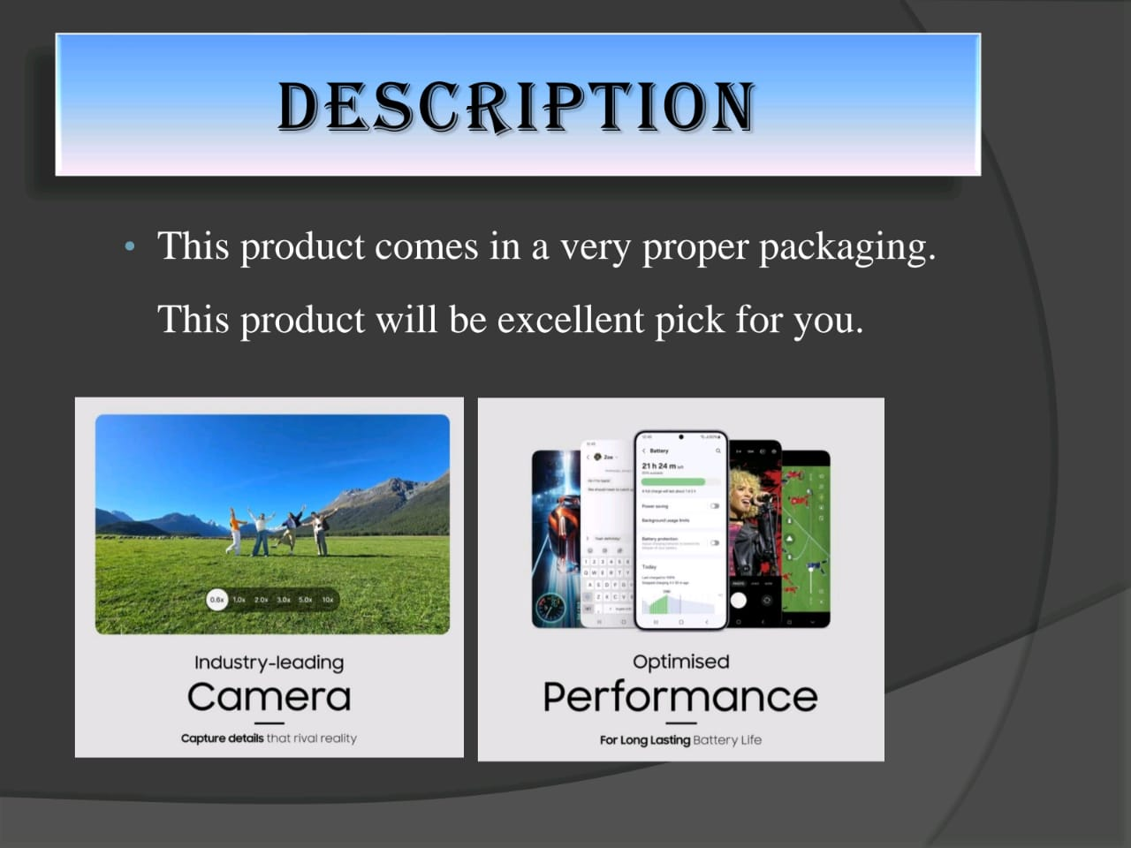

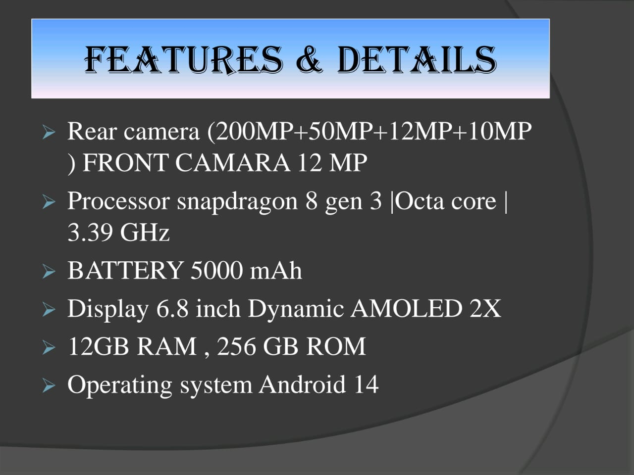

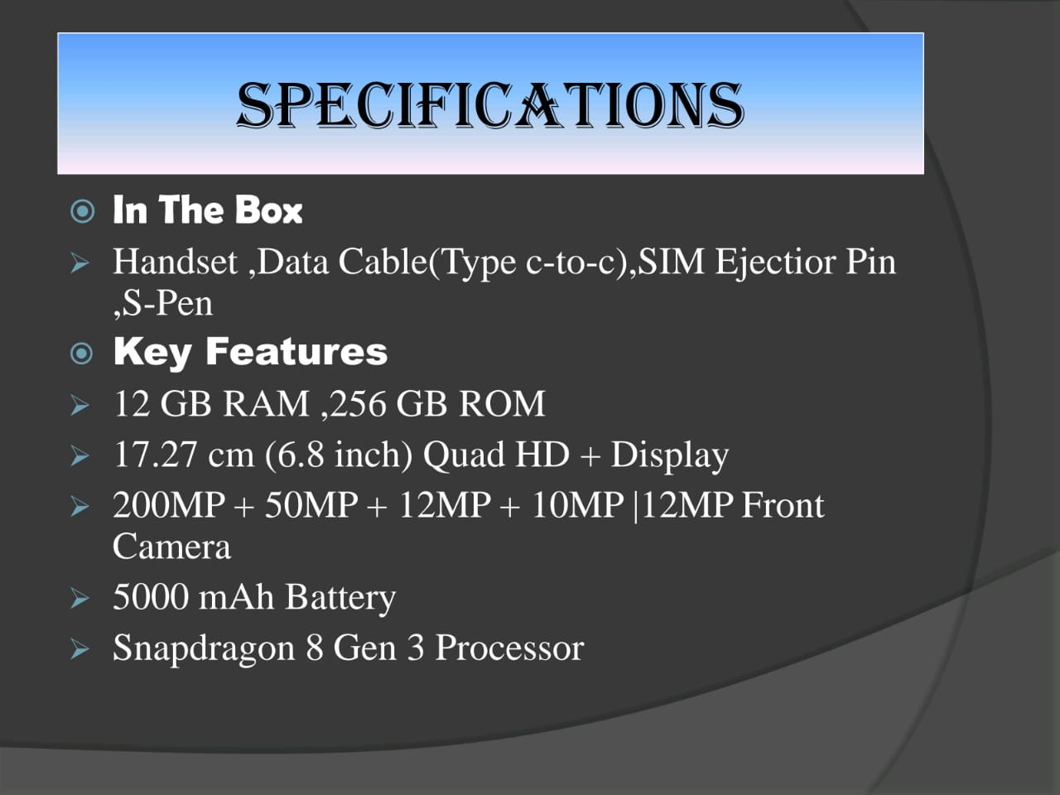

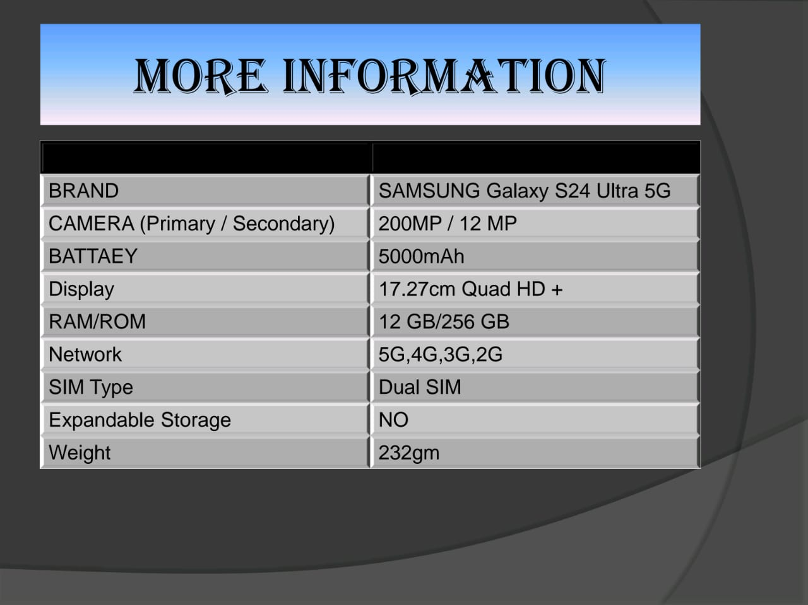

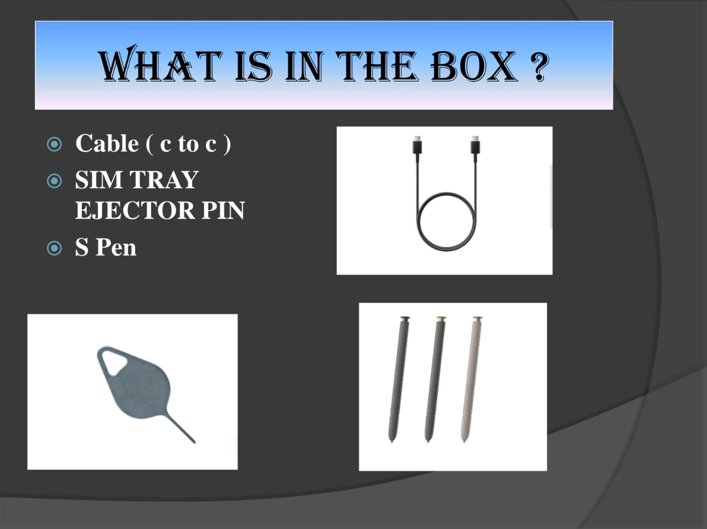

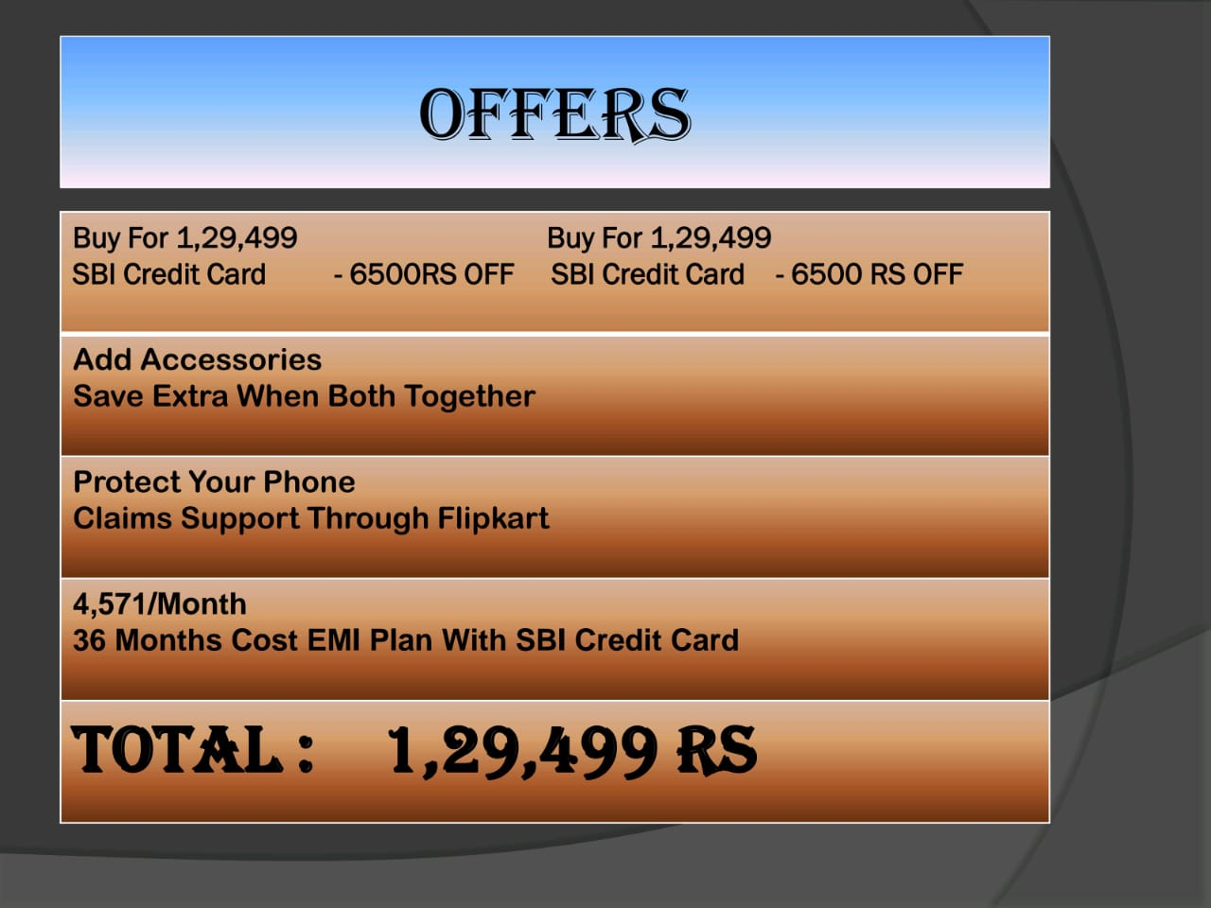





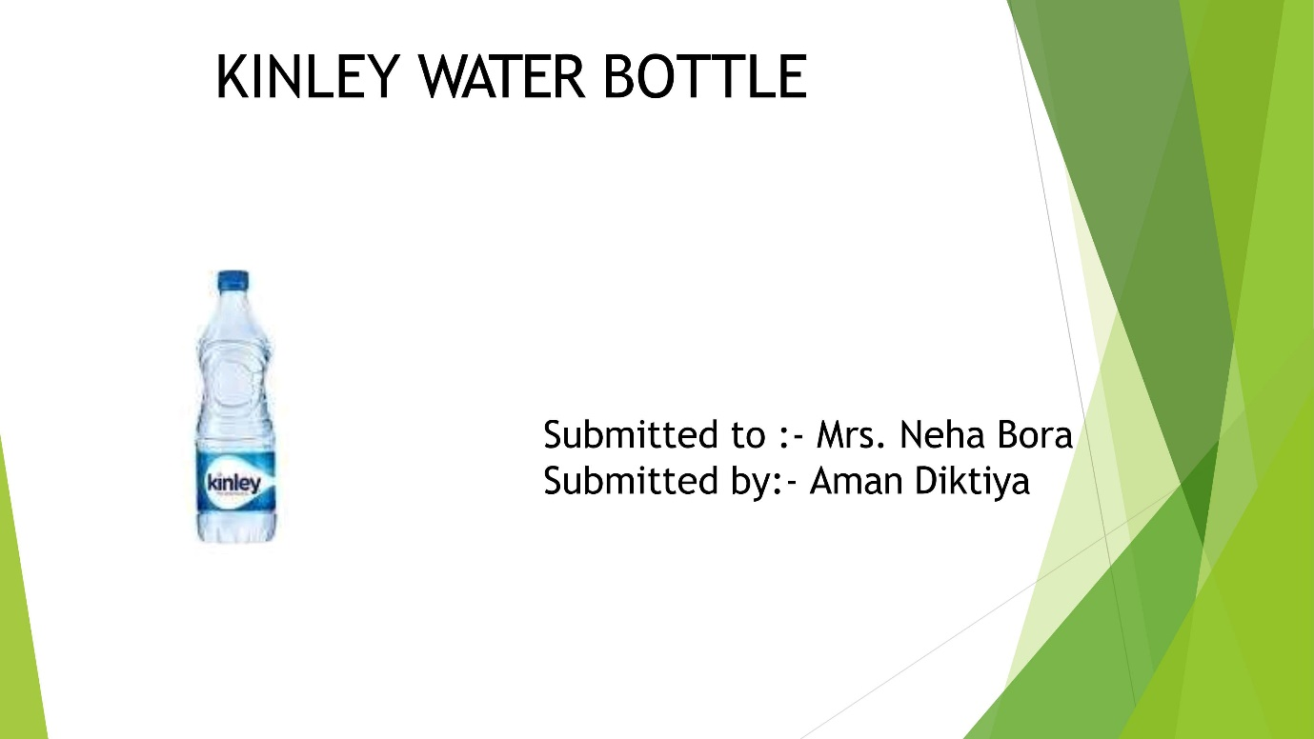



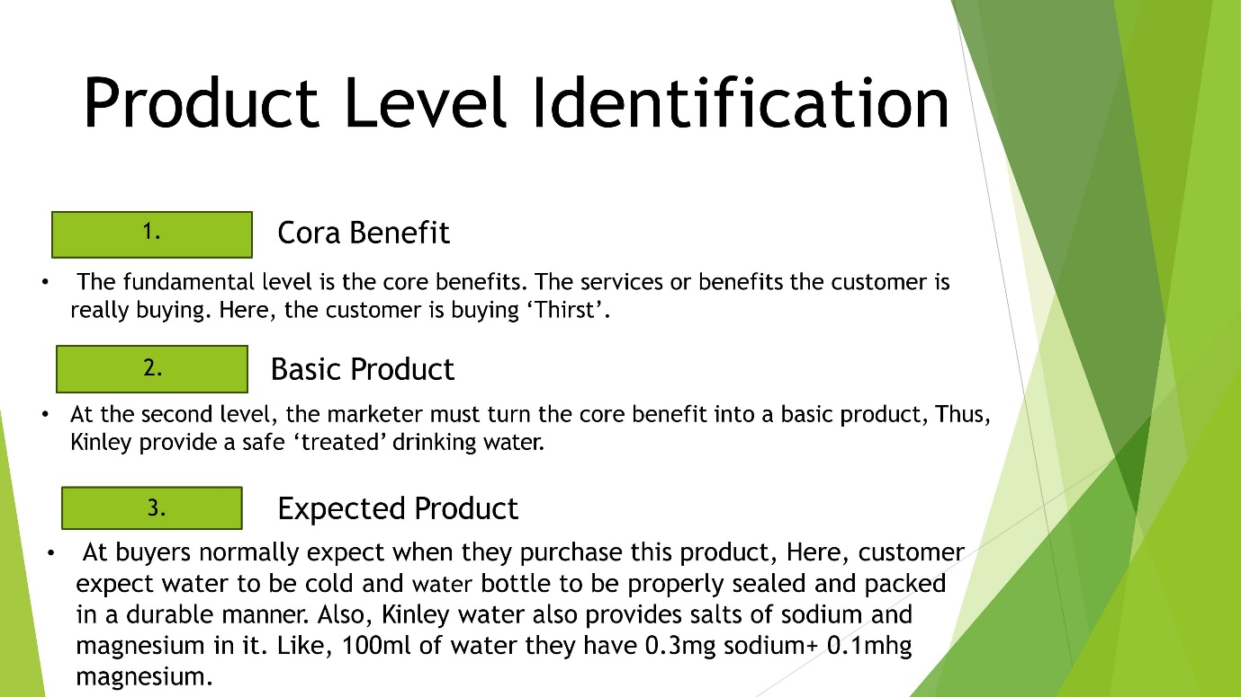

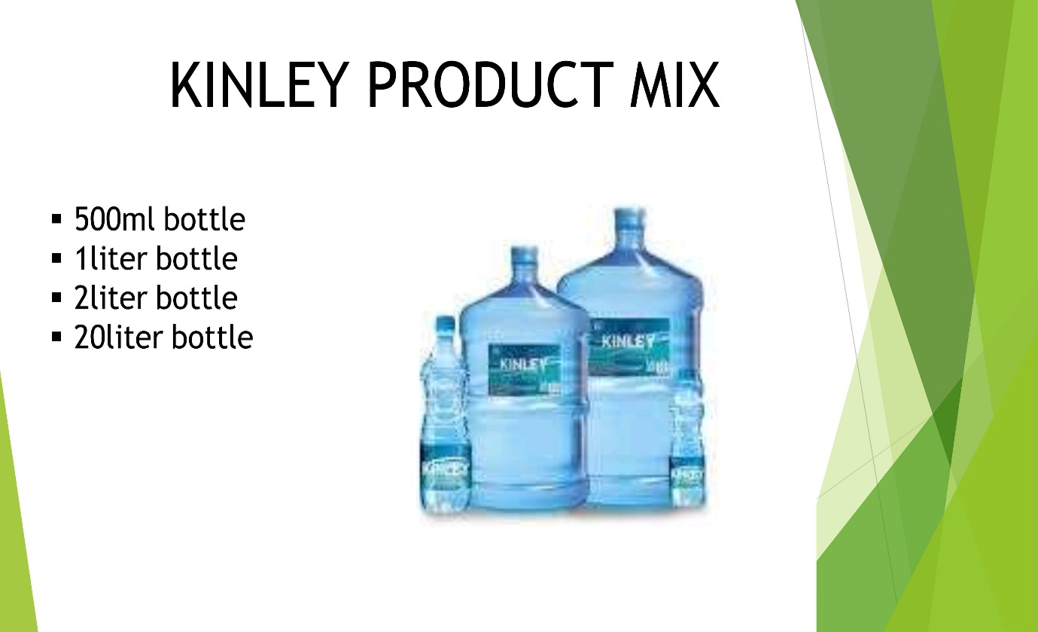

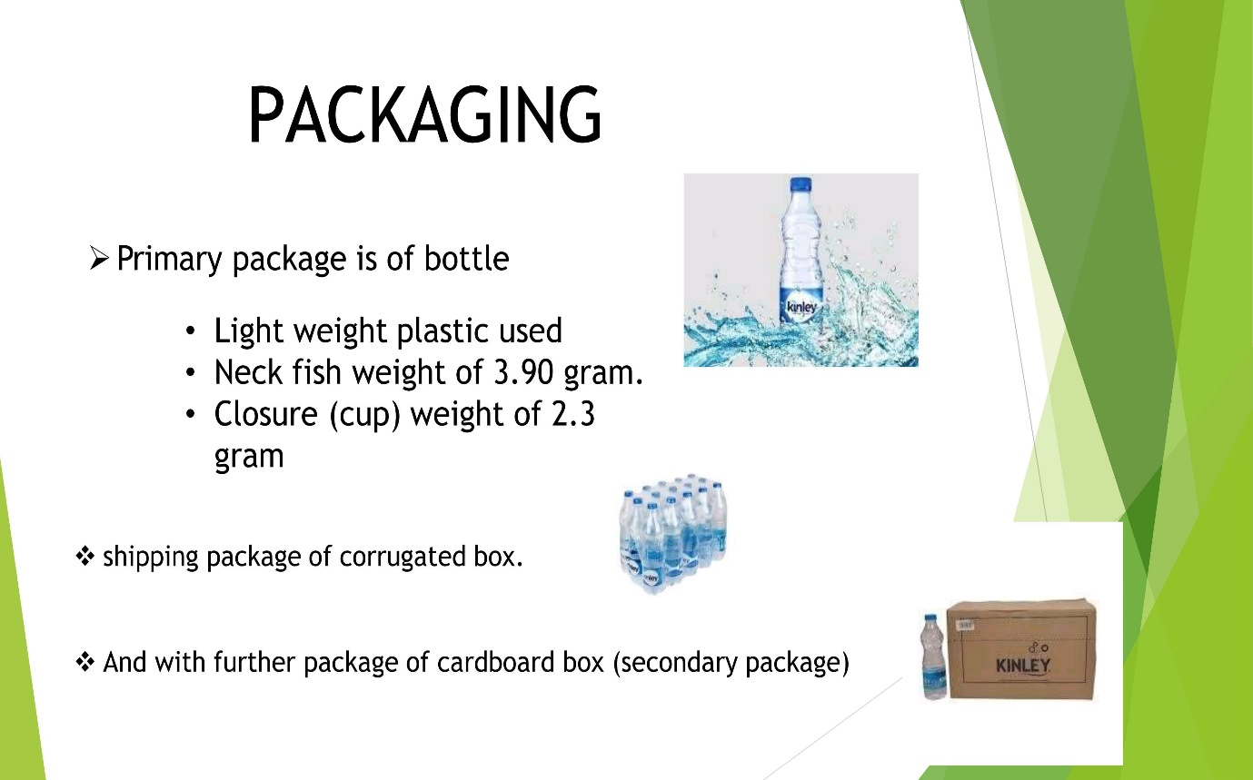



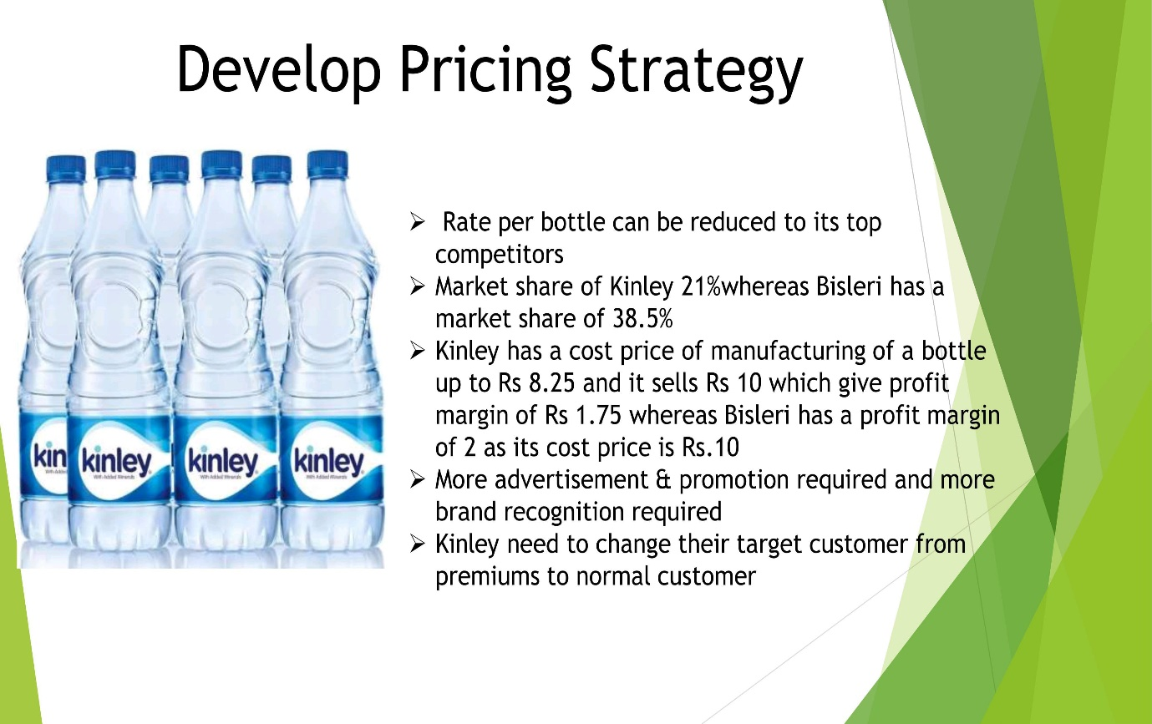



**DATE:**

**Practical: 11**

**Exercise:**

**Create presentation about our institution or any subject with different slides transition with sound effect.**

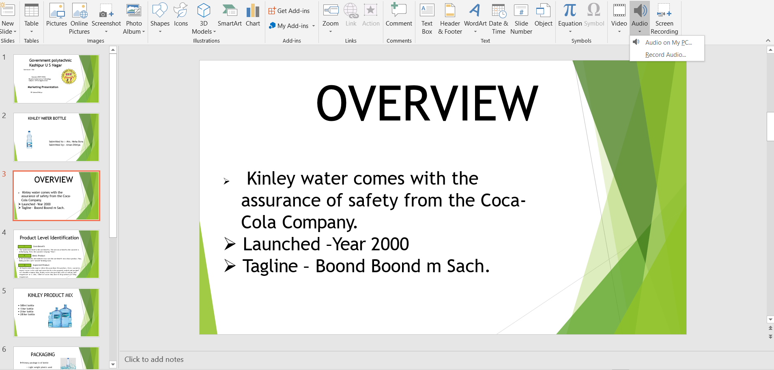

**DATE:**

**INTERNET:**

Internet, a system architecture that has revolutionized communications and methods of commerce by allowing various computer networks around the world to interconnect. Sometimes referred to as a “network of networks,” the Internet emerged in the United States in the 1970s but did not become visible to the general public until the early 1990s. By 2020, approximately 4.5 billion people, or more than half of the world’s population, were estimated to have access to the Internet.

**Getting acquainted with Internet Connection:**

Internet access is the ability of individuals and organizations to connect the Internet using computer terminals, computers, and other devices; and to access services such as email and the World Wide Web. Internet access is sold by Internet service providers (ISPs) delivering connectivity at a wide range of data transfer rates via various networking technologies. Many organizations, including a growing number of municipal entities, also provide cost-free wireless access and landlines. In addition to access from home, school, and the workplace Internet access may be available from public places such as libraries and Internet cafes, where computers with Internet connections are available. Some libraries provide stations for physically connecting users' laptops to local area networks (LANs). Wireless Internet access points are available in public places such as airport halls, in some cases just for brief use while standing. Some access points may also provide coin-operated computers. Various terms are used, such as "public Internet kiosk", "public access terminal", and "Web payphone". Many hotels also have public terminals, usually fee based.

**Browsers:**

A computer program with a graphical user interface for displaying and navigating between web pages. It is a software application for accessing information on the World Wide Web. When a user requests a web page from a particular website, the web browser retrieves the necessary content from a web server and then displays the page on the user's device. The first Web browser, called World Wide Web, was created in 1990. That browser's name was changed to Nexus to avoid confusion with the developing information space known as the World Wide Web. The first Web browser with a graphical user interface was Mosaic, which appeared in 1993. Many of the user interface features in Mosaic went into Netscape Navigator. Microsoft followed with its Internet Explorer (IE).

**Website URL:**

URL is the short form for Uniform Resource Locator, a website URL is the location of a specific website, page, or file on the Internet. Every URL is made up of multiple parts, and the way yours are built will have a variety of effects on your site’s security and Search Engine Optimization (SEO). For example, if you enter https://themeisle.com/blog/what-is-a-website-url/ in your web browser, your web browser will take you to this post. But if you just enter https://themeisle.com/, you get taken to the Theme isle homepage.

To Open a Website in a browser a user may simply enter a web URL belonging to the page of the respective website.

**Net Browsing:**

Net Browsing refers to opening a website through the web browser that contains hyperlink and with the help of these hyperlinks, jumping to a new web document in the same or a new window. It is also known as navigating or surfing the web. Browsing or searching in Internet environment is nothing but retrieving of relevant results from the Internet.

**E-Mail:**

Electronic mail (email or e-mail) is a method of exchanging messages ("mail") between people using electronic devices. Email entered limited use in the 1960s, but users could only send to users of the same computer, and some early email systems required the author and the recipient to both be online simultaneously, similar to instant messaging. Ray Tomlinson is credited as the inventor of email; in 1971, he developed the first system able to send mail between users on different hosts across the ARPANET, using the @ sign to link the user name with a destination server. By the mid- 1970s, this was the form recognized as email.

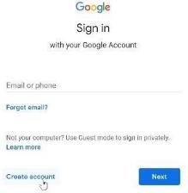**Creating E-Mail Id:**

It’s easy and free to set up a new email address. The best way to do this is to set up something called a webmail account. This is a type of email account can be accessed from any computer by logging into account securely. Typical webmail services include Google’s Gmail (gmail.com) and Microsoft’s Outlook.com (outlook.com). They’re both reliable, free choices also there are many more choices such as Yahoo Mail etc.

**Creating an Id on Gmail**

* Go to www.gmail.com.
* Click Create account.
* Next, enter phone number to verify account. Google uses a two step verification process for your security. Next, user will see a form to enter some personal information, like name and birthday.
* User will receive a text message from Google with a verification code. Enter the code to complete the account verification.
* Review Google's Terms of Service and Privacy Policy, then click I agree. User account will be created.

**Sending, Receiving and Deleting E-mail**

**To send an Email**

* Click on Compose
* Fill the required recipients & subject in the newly appearing window .
* Write the desired message.
* Click on Send.

The required message will be sent to its destination.

Receiving Emails are as easy as sending mails. To Receive Emails the created Id or receiver’s respected Email Id should be with the sender. The sender can now recipient the receiver’s Id in order to send the desired Email to the receiver.

To Delete Emails the user may simply the select the desired Email to be deleted & click on delete which appears by right clicking on the respected email.

**Email with Attachments:**

Email attachments are files that are attached to email messages, thereby increasing the potential value or benefit of that message to the recipient. These may be files of different formats, sizes, and contents. Attachment can be in text files, documents, spreadsheets, and PDF's form. User may attach required files by choosing from the files dialogue box which appears after clicking on attach icon.

**CC and BCC:**

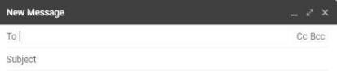 In email sending, CC is the abbreviation for “carbon copy.” Back in the days before internet and email, in order to create a copy of the letter you were writing, you had to place carbon paper between the one you were writing on and the paper that was going to be your copy. Just like the physical carbon copy above, CC is an easy way to send copies of an email to other people. BCC stands for “blind carbon copy.” Just like CC, BCC is a way of sending copies of an email to other people. The difference between the two is that, while you can see a list of recipients when CC is used, that’s not the case with BCC. It’s called blind carbon copy because the other recipients won’t be able to see that someone else has been sent a copy of the email.

**Chatting:**

Steps to chat in Gmail

Open the Gmail app.

* At the top left, tap Menu >Settings.
* Select your account.
* Check or uncheck the Show the chat and rooms tab box to turn Chat on or off. Now a chat can be started and the old chats can be seen from the newly opened window.

**Creating Group:**

Steps:

* Visit Google Contacts.
* Click “Contacts”, “Frequently contacted” or “Directory”.
* Select the contacts you want to include in your group.
* Choose the “Label” icon and press “Create Label”. Now user can name the label and type group’s name in the recipient’s box to send an email to them.

**Google Docs:**

Google Docs is an online word processor that lets you create and format documents and work with other people. It is a word processor included as part of the free, web-based Google Docs Editors suite offered by Google. The service also includes Google Sheets, Google Slides, Google Drawings, Google Forms, Google Sites, and Google Keep. Google Docs is available as a web application, mobile app for Android, iOS, Windows, BlackBerry, and as a desktop application on Google's Chrome OS. The app is compatible with Microsoft Word file formats.

**Search Engines:**

A search engine is a web-based tool that enables users to locate information on the World Wide Web. Popular examples of search engines are Google, Yahoo!, and MSN Search. Search engines utilize automated software applications that travel along the Web, following links from page to page, site to site. The information gathered by the spiders is used to create a searchable index of the Web. Searching Topics Every search engine uses different complex mathematical formulas to generate search results. The results for a specific query are then displayed on the SERP. Search engine algorithms take the key elements of a web page, including the page title, content and keyword density, and come up with a ranking for where to place the results on the pages.

**POPULAR SOCIAL NETWORKING SITES**

FACEBOOK is an American online social media and social networking service based in Menlo Park, California, and a flagship service of the namesake company Facebook, Inc. It was founded by Mark Zuckerberg, along with fellow Harvard College students and roommates Eduardo Saverin, Andrew McCollum, Dustin Moskovitz, and Chris Hughes.

**HISTORY**

Zuckerberg built a website called "Facemash" in 2003 while attending Harvard University. The site was comparable to Hot or Not and used "photos compiled from the online face books of nine Houses, placing two next to each other at a time and asking users to choose the "hotter" person”. In January 2004, Zuckerberg coded a new website, known as "The Facebook", inspired by a Crimson editorial about Facemash, stating, "It is clear that the technology needed to create a centralized Website is readily available the benefits are many." Zuckerberg met with Harvard student Eduardo Saverin, and each of them agreed to invest $1,000 in the site. On February 4, 2004, Zuckerberg launched "The Facebook", originally located at thefacebook.com.

**FEATURES:**

* **Photo/Video** :

This may be the most popular use of Facebook. It was Sean Parker's idea, Scott Marlette engineered it, and the application launched in October 2005. Desired Photos & Videos can be shared through this option globally on Facebook.

* **News Feed** :

This was the update that launched a million protest groups. Zuck's response: "Calm down. Breathe. We hear you." In the end, we breathed, we came around to the idea, and now we can't imagine our online social lives without it. This is the most important feature of Facebook ever & the main reason why Facebook is called a social media website.

* **The Like/Comment Button**

Before the Like button, to approve of another person's post, you had to write, "Like" or, "Yeah!" or, "Wow, I like that too LOL!" Those were dark times.

* **Messenger**

We all thought we didn't need another chat platform. Turns out that yet again, we were wrong and Zuck was right. Now it's in the top 75 most downloaded apps in Apple's App store.

* **Events**

Face it, without Facebook events you wouldn't know what's going on. Through this feature one can create his or her own events & also watch or join a friend’s created Events, also they can be hided from a particular friend or a person.

**SERVICES:**

Facebook Services is a tool that lets user manage different Facebook services automatically using your Android device. In particular, the tool focuses on searching for nearby shops and establishments based on interests. Likewise, the design of Facebook Services is quite simple. Up top a search bar is located where user can type in the kind of business to find. It offers a bunch of info on lots of businesses, in seconds user will have a list of the establishments that best suits the needs. It also displays a map showing the different businesses. Something quite like what Google Maps does. User enjoys basic tools to find info on the location of certain products and services.

**TRANSFERRING DATA THROUGH BLUETOOTH:**

PC to Android & Vice Versa Steps:

* Make sure your PC’s Bluetooth is on. If active, you’ll see the icon in the ‘System Tray.’ The icon will also display in the ‘Action Center’ whether Bluetooth is on or off.
* Once Bluetooth is enabled, right-click the icon in the ‘System Tray’ and select “Add a Bluetooth Device.” • In the Bluetooth Settings window, select “Add Bluetooth or other devices.”
* In the ‘Add a Device’ popup menu, select “Bluetooth” to search for your Android device. On Android, you may need to open your Bluetooth settings and hit the refresh icon to reactivate search-and- find functionality, or Windows won’t discover it.
* Click on the device when it appears. You may also need to select the PC name on the Android device while Windows attempts to connect.
* Your PC will then show you a code to ensure that you’re connecting to the right device, which should also appear on your smartphone or tablet’s screen. Verify that the codes match, and then select “Yes.”

**INTRODUCTION TO CYBERCRIME**

Cybercrime is criminal activity that either targets or uses a computer, a computer network or a networked device. Most, but not all, cybercrime is committed by cybercriminals or hackers who want to make money. Cybercrime is carried out by individuals or organizations. Some cybercriminals are organized, use advanced techniques and are highly technically skilled. Others are novice hackers. Rarely, cybercrime aims to damage computers for reasons other than profit. These could be political or personal.

Types of Cybercrime Here are some specific examples of the different types of cybercrime:

* Email and internet fraud.
* Identity fraud (where personal information is stolen and used).
* Theft of financial or card payment data.
* Theft and sale of corporate data.
* Cyberextortion (demanding money to prevent a threatened attack).
* Ransomware attacks (a type of cyberextortion).
* Crypto jacking (where hackers mine cryptocurrency using resources they do not own).
* Cyberespionage (where hackers access government or company data).
* Most cybercrime falls under two main categories:
* Criminal activity that targets
* Criminal activity that uses computers to commit other crimes. Cybercrime that targets computers often involves viruses and other types of malware. Cybercriminals may infect computers with viruses and malware to damage devices or stop them working. They may also use malware to delete or steal data

**Malware Attacks**

A malware attack is where a computer system or network is infected with a computer virus or other type of malware. A computer compromised by malware could be used by cybercriminals for several purposes. These include stealing confidential data, using the computer to carry out other criminal acts, or causing damage to data.

**Phishing**

A phishing campaign is when spam emails, or other forms of communication, are sent en masse, with the intention of tricking recipients into doing something that undermines their security or the security of the organization they work for. Phishing campaign messages may contain infected attachments or links to malicious sites. Or they may ask the receiver to respond with confidential information.

**Distributed DoS Attacks**

Distributed DoS attacks (DDoS) are a type of cybercrime attack that cybercriminals use to bring down a system or network. Sometimes connected IoT (internet of things) devices are used to launch DDoS attacks. A DDoS attack overwhelms a system by using one of the standard communication protocols it uses to spam the system with connection requests. Cybercriminals who are carrying out cyberextortion may use the threat of a DDoS attack to demand money. Alternatively, a DDoS may be used as a distraction tactic while other type of cybercrime takes place.

**SOFTWARE PIRACY**:

Software piracy is the act of stealing software that is legally protected. This stealing includes copying, distributing, modifying or selling the software. Copyright laws were originally put into place so that the people who develop software (programmers, writers, graphic artists, etc.) would get the proper credit and compensation for their work. When software piracy occurs, compensation is stolen from these copyright holders. Under the Indian Copyright Act, a software pirate can be tried under both civil and criminal law. The minimum jail term for software copyright infringement is seven days, and the maximum jail term is three years. Statutory fines range from a minimum of 50,000 to a maximum of 200,000 rupees. Sections of The IT Act, 2000 can also be applied based on scenario of piracy.

**VIRUSES:**

A Computer Virus is a type of malicious code or program written to alter the way a computer operates and is designed to spread from one computer to another. A virus operates by inserting or attaching itself to a legitimate program or document that supports macros in order to execute its code. In the process, a virus has the potential to cause unexpected or damaging effects, such as harming the system software by corrupting or destroying data. Once a virus has successfully attached to a program, file, or document, the virus will lie dormant until circumstances cause the computer or device to execute its code. In order for a virus to infect your computer, you have to run the infected program, which in turn causes the virus code to be executed. This means that a virus can remain dormant on your computer, without showing major signs or symptoms. However, once the virus infects your computer, the virus can infect other computers on the same network. Stealing passwords or data, logging keystrokes, corrupting files, spamming your email contacts, and even taking over your machine are just some of the devastating and irritating things a virus can do.

**ANTIVIRUS SOFTWARE**

Software that is created specifically to help detect, prevent and remove malware (malicious software). It is a kind of software used to prevent, scan, detect and delete viruses from a computer. Once installed, most antivirus software runs automatically in the background to provide real-time protection against virus attacks.

**Working**

Antivirus Software begins operating by checking computer programs and files against a database of known types of malware. Since new viruses are constantly created and distributed by hackers, it will also scan computers for the possibility of new or unknown type of malware threats. Typically, most programs will use three different detection devices: specific detection, which identifies known malware; generic detection, which looks for known parts or types of malware or patterns that are related by a common codebase; and heuristic detection, which scans for unknown viruses by identifying known suspicious file structures. When the program finds a file that contains a virus, it will usually quarantine it and/or mark it for deletion, making it inaccessible and removing the risk to your device.

**DATE:**

**EXERCISE:**

**B5. Create an e-mail id and perform the following**

* **Write an e-mail inviting your friends to your Birthday Party.**
* **Make your own signature and add it to the e-mail message.**
* **Add a word attachment of the venue route**
* **Send the e-mail to at least 5 of your friends.**
* **Create a presentation on Google docs. Ask your friend to review it and comment on it. Use “Discussion” option for your discussions on the presentation.**

**Writing email:**

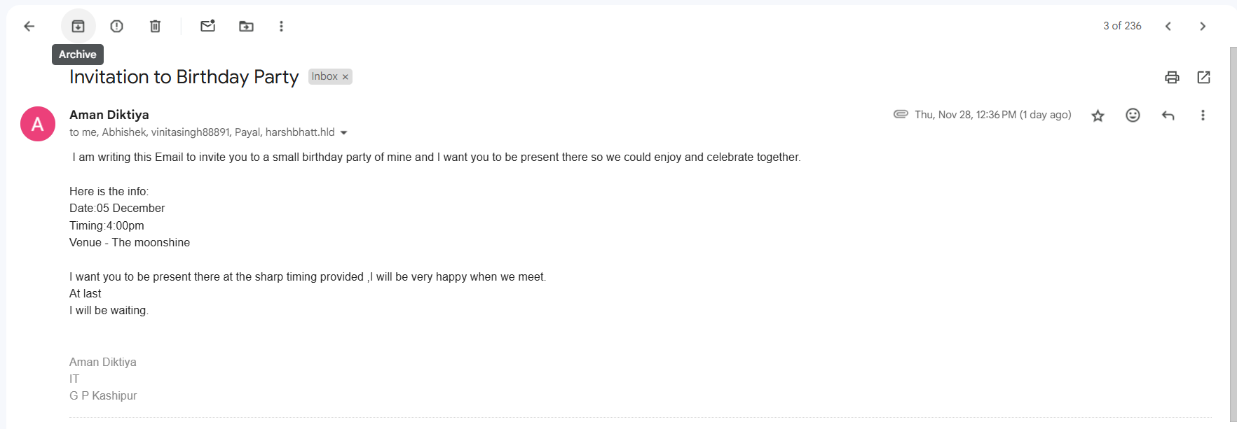

**Make your own signature and add it to the e-mail message.**

**settings > see all settings > signature**

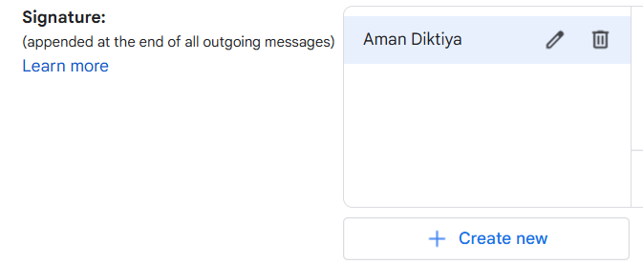

Word Attachment of the venue route may be selected from the newly appearing window of files after clicking on Attach files Icon.

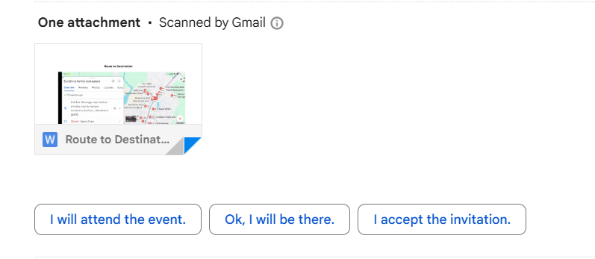

**Send Email to 5 friends:**

**Email of 5 friends is typed in the Recipients Box.**



**DATE:**

PRACTICAL: 13

Create a presentation open google docs ask to your friend and comment on it use “discussion” option for your discussion on the presentation.

